Using this template

This guide is designed to help your organization build a written safety program.

You’ll need to customize the template to fit your organization—it’s not ready to use as is. We’ve made that process easier by adding visual prompts throughout the document. Look for yellow-highlighted, red text that shows where you need to add or update information.

You can (and should) change any part of the template to match your organization’s structure, such as department names, job titles, responsibilities, or procedures.

Example
Before:
<COMPANY NAME>
Sample Safety Program

After:
XYZ Company
XYZ Safety Program

Formatting tips
- To remove the yellow highlighting: Select the highlighted text, then click the highlighter icon in the Font menu.
- To change the red font to black: Select the text and click the font color icon.
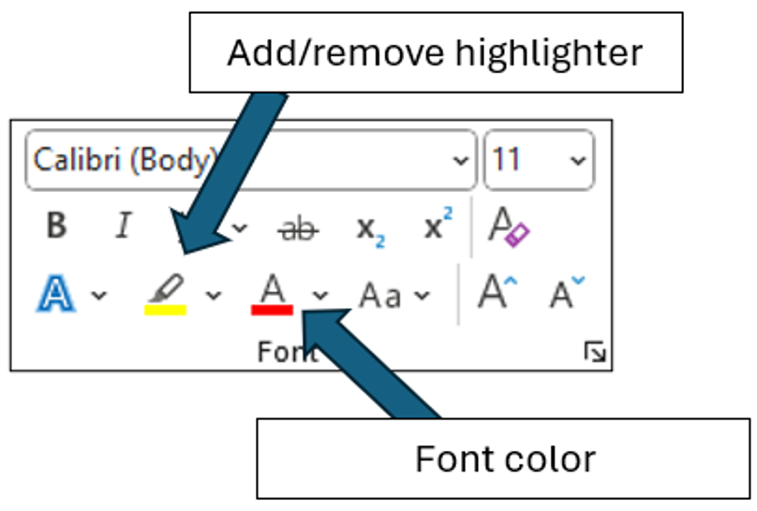

You’ll also see “Check your understanding” boxes throughout the template. These help you think through how to customize certain sections. After you’ve read and completed each one, simply right-click the box and select “Cut.”
Disclaimer. This sample safety program template cannot be used as is. You must customize the template to meet the needs of your organization. EMC does not guarantee that this template is or can be relied on for compliance with any law or regulation, assurance against preventable losses, or freedom from legal liability. We make no representations or warranties of any kind whatsoever, either express or implied, in connection with the use of this template. EMC will not be liable for your use of the template as customized by you. All safety programs and policies, including this template and the information you supply to complete it, should be reviewed by your legal counsel and/or risk management staff.
School Fleet Safety Program

Scope

The objective of this program is to reduce or eliminate motor vehicle accidents and associated injuries by following the safe practices established in this program. This program is integrated into the school district’s written safety and health program and is a collaborative effort that includes all employees.

Compliance with this program is mandatory for all school staff who drive vehicles for school business. Violations of this program may result in disciplinary action up to and including suspension of driving privileges or termination.
This Policy does not include additional state or local regulations that apply to school bus drivers.

Program Responsibilities

Management. is responsible for providing the tools and resources necessary to implement this program and for ensuring that the provisions in this program are being followed by the Program Administrator and all employees.

Program Administrator. The Program Administrator is responsible for the following:
- Evaluating prospective drivers
- Maintaining an accurate qualified drivers list
- Maintaining accurate qualification records
- Maintaining accurate substance abuse testing records
- Ensuring school vehicles are maintained
- Selection/procurement of all school vehicles
- Ensuring all qualified drivers are trained in the safe operation of the school district’s vehicles This should lead to the satisfactory completion of a road test)
- Monitoring drivers to ensure compliance with all elements of this program
- Coaching drivers using telematic data to improve driving habits or develop a driver mentorship program to coach drivers

Managers and Supervisors. Each supervisor, administrator, manager or director shall be directly responsible for the safe operation of all vehicles under his or her supervision and to:
- Provide driving orientation, training, and monitoring activities according to this policy, or arrange such orientation, training, and monitoring activities with Program Administrator.
- Enforce all provisions of this policy as it relates to the fleet drivers under his or her supervision.
- Coaching drivers using telematic data. In lieu of vehicle observations telematic data can be used to identify poor driving habits and coach drivers in the manner of how the vehicle should be operated. Telematics identify the harsh driving events and Appendix K-1 is used to document the coaching sessions had with each driver. Use Appendix K-1 for regular coaching sessions with the driver and in their annual performance review.

Drivers. staff who drive vehicles for school business are responsible for conducting themselves in accordance with this program. All drivers will:
- Meet all minimum qualification criteria (see below)
- Maintain an acceptable motor vehicle record (MVR)
- Be medically qualified to drive their assigned motor vehicle
- Maintain satisfactory evaluations from the Program Administrator and/or designated trainer
- Receive negative drug/alcohol tests
- Maintain a valid driver’s license appropriate for the vehicle to be driven. Drivers are to have this license in their possession at all times
- Immediately notify your supervisor when your driver's license has been suspended, revoked or restricted, or in the event of any accidents or if you receive a citation. Failure to do so may result in loss of driving privileges and/or termination of employment with

Note: A driver is anyone who may, in the course of their employment operate a school-owned motor vehicle, a rented/leased motor vehicle, and/or a personal motor vehicle on school business.

Driver Qualification – All Vehicle Types

will check the Motor Vehicle Record (MVR) of all driver applicants before they are granted driving privileges and obtain updated MVRs for all approved drivers annually thereafter. All annual reviews will be documented using the form in Appendix H. MVRs will also be checked whenever an employee is involved in a motor vehicle accident. A driver list is maintained and updated annually, and includes the last date of an MVR check for each driver. The approved drivers list will be recorded on the form found in Appendix C and maintained by the Program Administrator.
All employees whose job requires them to drive a school fleet vehicle shall meet the following criteria:
- At least twenty-one years of age
- At least three years of licensed driving experience
- Valid driver’s license appropriate for the vehicle to be driven
- Satisfactory MVR review
- Has not been convicted of any of the following violations within the previous five years:
  - Driving under the influence of alcohol and/or drugs
  - Open container violations
  - Reckless driving
  - Speeding 15 mph over the posted speed limit
  - Vehicular manslaughter
  - Using a vehicle to commit a felony
  - Hit and run/Leaving the scene of an accident
  - Fleeing/eluding police or resisting arrest
  - Operating a vehicle with a suspended or revoked license
  - Passing a stopped school bus
  - Railroad crossing violation
- Has not experienced any of the following within the previous three years:
  - Two “at fault” accidents
  - Three moving violations
  - Two moving violations and one “at fault” accident
  - Tested positive for drugs or alcohol while employed by the district
- All new employees whose job description includes driving a vehicle shall complete the new driver orientation and training program prior to being added to the approved driver list.
- No employee or nonemployee (for example, a student or an employee’s spouse) is allowed to operate a school fleet vehicle unless the Program Administrator has authorized that person to drive.

Additional Qualification Criteria - Bus Drivers

All drivers who are operating a commercial motor vehicle designed to transport more than 16 people are required to possess a valid Commercial Driver's License (CDL) with endorsements appropriate to the vehicle to be driven and as required by the state of . Commercial driver applicants will not be considered for employment unless they meet the minimum requirements listed below:
- Possess a current and valid commercial driver’s license or chauffer’s license with passenger and school bus driver endorsements
- Pass all background checks required by local, state and federal guidelines
- Possess a school bus operator’s certificate
- Be certified in basic first aid
- Be physically and mentally qualified to drive a school bus, per ‘s CDL manual
- Be able to read and speak English sufficiently to converse with students and the general public, to understand highway traffic signs and signals, to respond to official inquiries and to make entries on reports and logs
- Be able to perform all the tasks and essential duties of their job description
- Have at least two years of verifiable driving experience with like-type vehicles

Driver Training. Upon initial assignment of driving privileges, each driver will be required to attend a training session that outlines the rules and procedures in our Fleet Safety Program. Ongoing training will be offered to all drivers, at least annually, to ensure they are kept up-to-date with defensive driving techniques and changes to the program. Driver ride-a-longs may also be conducted upon initial hire and periodically thereafter as deemed appropriate by the Program Administrator. Training and retraining will be documented by the Program Administrator (Training Record/Certification forms are in Appendix B).
Motor Vehicle Record Review

All employees whose job description includes driving a school fleet vehicle, even occasionally, shall have their MVR reviewed annually. All annual reviews will be documented using the form in Appendix H. Each listed driver must meet the driver qualification criteria listed above.
A driving record (MVR) will be reviewed annually for all school bus drivers according to the legal requirements of the State of . Eligibility to operate a school bus will be determined by that review.

All drivers for are expected to maintain a driving record that reflects good driving habits. Drivers are required to immediately notify their supervisor when their driver's license has been suspended, revoked or restricted, or in the event of any accidents or receipt of any citations. Failure to do so may result in loss of driving privileges and/or termination of employment with .

Any employee not meeting the MVR acceptability criteria will be notified that his or her driving privileges have been suspended. If current duties cannot be performed without driving, the employee may be reassigned to an available, non-driving position for which the employee is qualified. If no such position is available, the employee may be terminated.
Any deviations from the above MVR acceptability criteria require the written approval of the Superintendent.

Driver Safety Rules

Drivers must obey all state laws and posted signs when operating vehicles. In addition, the following rules must be followed at all times.
Cell Phones and Other Distractions. The use of handheld or hands-free cell phones or other devices that take attention away from driving are prohibited when driving school vehicles. Passengers may use devices only if the use will not be distracting to the driver. Cell phone calls should be made prior to or at the completion of a trip. If a call must be made during a trip, drivers must pull into a safe location and stop before making the call. If the driver receives an incoming call while driving, they must allow the call to go to voicemail and return the call when stopped in a safe location. Eating while driving is prohibited. Nonalcoholic drinks may be consumed with great discretion and only in situations where driving hazards are minimal (i.e., not in traffic, through road construction, etc.).
Seat Belts. Seat belts must be properly worn by all drivers and passengers while the vehicle is in operation. Children being transported in a school vehicle other than a school bus must remain properly secured in a child safety seat or booster seat according to state law.
Drugs and Alcohol. Drivers will not operate a motor vehicle at any time while under the influence of alcohol, illegal drugs, medication, illness, fatigue or injury. The sale, purchase, transfer or possession of any controlled substance (except medically prescribed drugs) is strictly prohibited while using a school vehicle, while on the school district premises or while engaged in school district business.
Severe Weather. Extreme caution must be exercised when driving in severe weather conditions. If a driver has any doubt about the safety of travel, they must contact their supervisor or the Program Administrator for guidance.
Radar Detectors. The use of radar detectors or any other device with the purpose of detecting or interfering with police radar is prohibited.
Glass. Damaged glass should be reported immediately to the Program Administrator. To reduce windshield damage, drivers will:
- Keep a safe distance between vehicles, especially on gravel roads
- Use clean, greaseless, dry cloths to wipe the windshield
- Replace worn wiper blades as soon as they begin to streak
- Use plastic or rubber ice scrapers, never metal
Towing. Only vehicles specifically approved for towing by the Program Administrator may be used to tow trailers of any size or type.

Accidents and Citations
Traffic citations must be reported to the Program Administrator as soon as possible. The Program Administrator will review the driving privileges of any employee charged with a serious offense. Disciplinary action may include warnings, probation or suspension of driving privileges. For those jobs that require operation of a fleet vehicle, loss of driving privileges may result in termination.
Vehicle Accident Investigation. Vehicle accident investigations are handled internally and may utilize external documents such as police reports. Vehicle accident reports are to be filled out by the driver and returned to the Program Administrator as soon as reasonably possible. The Program Administrator will determine accident preventability and the proper course of disciplinary action that might be necessary. The Program Administrator will also determine if additional training is needed to prevent similar accidents from occurring in the future. Trends in types of accidents or multiple accidents by the same driver will receive additional scrutiny, as they may signal the need for additional training or changes to driver selection procedures.
When in an accident, drivers must:
- Stop the vehicle and protect the scene to prevent a secondary accident
- Activate flashers
- Call for medical assistance and assist any injured people, if necessary
- Call the police and the Program Administrator or supervisor as soon as possible
- Locate any witnesses and get important information from them. If possible, get names, addresses and phone numbers
- Exchange pertinent information with other drivers
- Take photos of the accident
- Fill out a vehicle accident report form and send it to the Program Administrator (forms are in Appendix D)
- Never admit fault or apologize. Apologies could be interpreted as an admission of fault
- Never argue with other drivers or witnesses
- Never argue with the police
- Never make a statement to the media. Refer them to the Program Administrator
- Never discuss details of the incident with anyone except a representative of or the police

Additional guidelines for school bus drivers:
- Check for injuries
- Determine if evacuation is necessary. Students should remain on the bus unless conditions are too dangerous
- Evacuate if fuel is spilled, bus is overturned, or fire danger exists
- Radio or call dispatch for help. Stay with vehicle – do not leave to assist other vehicle(s)
- Appoint bus assistant and place triangle reflectors at 10’ and 100’ behind bus, 100’ in front
- Reassure students that the situation is in control
- Follow “Transfer of Students” procedures if necessary
- Follow “Post-Crash” procedures

Note: Every motor vehicle is required to have a vehicle accident reporting kit in the glove box. This kit should be used by the driver to record accident facts after the accident as soon as feasible. If the vehicle you are driving does not have a Vehicle Accident Report form in it, contact the Program Administrator.

Reporting Vehicle Accident Involving Employee Injury
- Employees injured on the job are to report the injury to the Program Administrator as soon as possible
- The Program Administrator is to follow the established employee injury or accident investigation program

The goal of this reporting and investigation process is not to find fault, but to determine the root cause so that corrective actions can be made in order to prevent future accidents or incidents.

Vehicle Accident Report Retention. Vehicle accident reports and associated information will be maintained by the Program Administrator for three years after the date of the vehicle accident.
The following information will be retained:
- Date of accident
- City and state in which the accident occurred
- Driver name
- Number and nature of injuries
- Copy of vehicle accident report
- Copies of all accident reports required by state or other governmental entities or insurers

Post-Accident Corrective Action Procedure. The Program Administrator will evaluate driver performance after an accident. The corrective actions below will apply if a driver experiences an accident that is judged to be preventable. Accidents will be judged on a case-by-case basis before the corrective action program is initiated.

- A driver who is involved in one preventable accident in six months will be placed on probation for 90 days
- If the driver successfully completes that period of probation without any further accidents, the driver will be taken off the probation list
- If the driver is involved in another preventable accident while on probation, the driver will be subject to further disciplinary action, up to and including termination

also reserves the right to impose more stringent consequences based on the circumstances and/or severity of a preventable accident.

Vehicle Inspections and Maintenance

To extend the useful life of vehicles, regular inspections and maintenance should be completed on all vehicles per the manufacturer’s recommendations. If during an inspection any of the items are found to be unsatisfactory the vehicle will be removed from service until it can be repaired or replaced. All problems should be promptly reported to the Program Administrator. Each driver will inspect the vehicle before each use. The inspection will consist of all items listed in the Vehicle Self-Inspection Report (form located in Appendix E). All vehicle Self-Inspection Reports will be submitted to the Program Administrator within one business day.
In states that require emissions testing, all vehicles will comply with the state’s requirements.
Daily Pre-Trip Bus Inspection
All school bus drivers will inspect their bus daily before use. The inspection will consist of all items listed in the Bus Driver’s Daily Pre-Trip Inspection Report (form located in Appendix F). All inspection reports will be submitted to the Program Administrator within one business day.
- Exterior Inspection – Walk around the bus, checking the following items:
- Tires – condition of tread and proper inflation
- Lug nuts
- Windows and light lens covers - condition and cleanliness
- Mirrors – condition and cleanliness, adjusted for driver
- Body damage
- Under bus – loose parts or fluid leaks
- Overall cleanliness
- Wheelchair lift

- Check Lights – Set parking brake, be sure engine is off and then check the following items:
- Headlights (low and high beams)
- Turn signals
- Emergency flashers
- Backup lights
- Brake lights
- Side marker lights

- Check Engine Compartment – After verifying the parking brake is set and/or wheels chocked, the driver will raise the hood and inspect the following items in the engine compartment:
- Fluid levels
- Belts and hoses for cracks or wear
- Belt tension
- Damaged or worn electrical wiring insulation

- Start Engine and Inspect Inside the bus – The driver will verify that the parking brake is set, place gearshift in neutral, start engine and listen for unusual noises. Then check the following:
- Gauges and indicators (oil, ammeter/voltmeter, coolant temperature, engine oil pressure, warning lights)
- Brake pedal height and feel
- Windshield wipers and washer fluid
- Steering – full range of motion and no unusual noises
- Verify the visibility of mirrors and windshield and mirror adjustability
- Check heater and defroster blowers
- Location of emergency equipment, first aid kit and fire extinguisher
- Radio – radio check with dispatch

The driver must also note any other defects that could affect the safe operation of the vehicle or result in its mechanical breakdown. The report must also indicate if no defects are found. The driver must sign and submit the report to the Program Administrator.

The original copy of the inspection report and certification of repairs will be retained in the vehicle maintenance files. The original copies of inspection reports on which defects were noted and the certification of repairs will be retained for three months.

Vehicle and Equipment Selection.
Vehicle Replacement Schedule –

Vehicles will be replaced regardless of their age or mileage if safety-based repairs cost more than the value of replacement.

The make and model of power units are dictated by a number of factors including, but not limited to, replacement cost, safety features, service availability, warranty, standard features and operating costs.

Safety Features -- All new power units will have the following minimum safety features:

- Disc brakes
- Stability control
- Convex mirrors
- Rear-end avoidance system
- GPS tracking

All single vehicle units will be equipped with rear view cameras.

Periodic Program Review
At least annually, the Program Administrator will conduct a program review to assess the progress and success of the program. The review will consider the following:
- Review current drivers to the list of Qualified Drivers List (Appendix C)
- Evaluation of all training programs and records
- The need for retraining of management and/or drivers based on accident investigation results
- Review the drivers that have a high number of vehicle accidents
- Responsiveness in reporting vehicle accidents
- Vehicle purchases and safety equipment contained on the vehicles
- The program’s success will be determined and reported to senior management using the following criteria:
- Cost and frequency of vehicle accidents
- Employee feedback through direct interviews, audits and questionnaires
- Vehicle accident investigation results
The Annual Review Report Form found in Appendix A will be used for the review.

Records Retention
All records not otherwise identified in this program will be retained for years
Revision History
12/10/2024

Appendix A – Annual Evaluation Report

Date of Evaluation: | Evaluated by (list all present):
Written Program Reviewed: Yes No

Do vehicle accident records indicate a need for additional driver training on the School Fleet Safety program? Yes No

Have any drivers produced a high incidence of vehicle accidents? Yes No
If yes, list:

Is there any record of failure to report vehicle accidents in a timely manner?
If yes, what corrective action is needed?

The following content was added/modified/removed from the written program:
Comments:

Appendix B – Training Record/Certification Document

The following individuals received training on the Fleet Safety Program.

Print Name | Sign Name

Print Instructor’s Name
Instructor’s Signature
Instructor’s Title
Date of Training

Appendix C – Qualified Driver List

Driver Name | DL # | DL Type | Endorsements | Hire Date | Date Last MVR | Date of Driver Training

Appendix D – Vehicle Accident Report

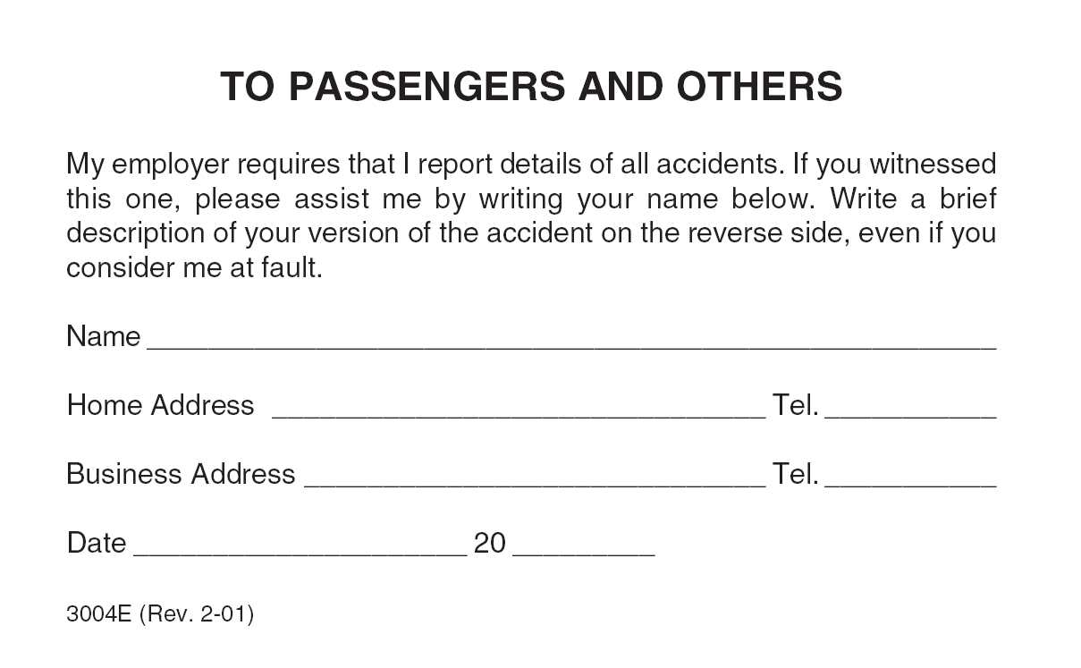
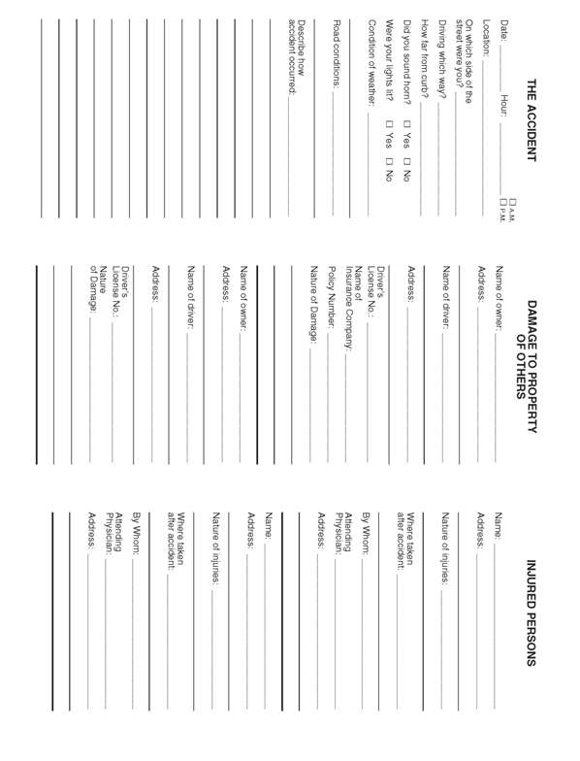

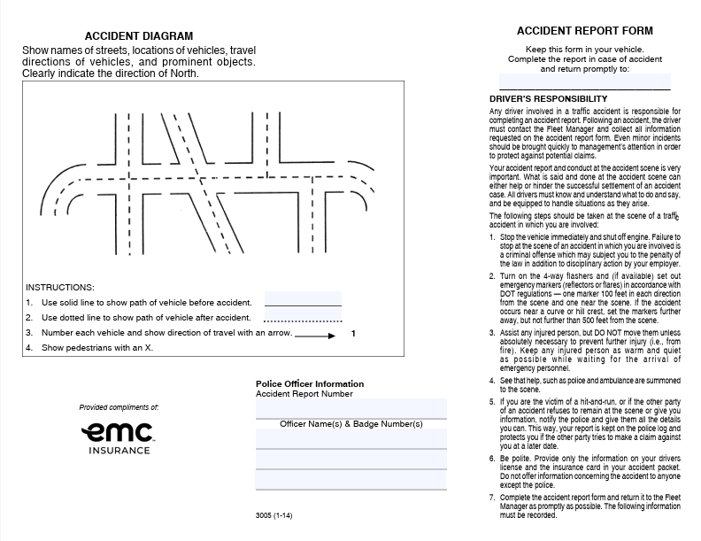
Appendix E –Vehicle Self Inspection Report

If an item is defective, check the box and give details in the remarks section.

Inspection Completed By: |  |  |  |  |  |  |  |  |  |  | Date:
Vehicle Make: |  |  | Model: |  |  | Year: |  |  |  | No.:
Beginning Mileage: |  |  |  |  | Ending Mileage:
Not OK | OK | Before Starting Engine |  |  |  |  | Not OK | OK | After Starting Engine
 |  | Body |  |  |  |  |  |  | Brakes
 |  | Brake/head/tail/clearance lights |  |  |  |  |  |  | Parking brake
 |  | Direction signals/emergency flashers (4-way) |  |  |  |  |  |  | Engine/drive train
 |  | Mirrors (inside and outside) |  |  |  |  |  |  | Gauges (oil/fuel/temp/air)
 |  | Windows/windshield |  |  |  |  |  |  | Heater/defroster/air conditioner
 |  | Wheels and tires |  |  |  |  |  |  | Speedometer
 |  | –Air pressure to manufacturers recommendation |  |  |  |  |  |  | Steering
 |  | –Minimum of ³/₁₆ inch tread depth |  |  |  |  |  |  | Transmission
 |  | –No visible sign of the tire deterioration |  |  |  |  |  |  | Other:
 |  | Windshield wipers and washers
 |  | Horn
 |  | Seat belts (all seating positions) |  | Remarks:
 |  | Seats securely fastened to the floor
 |  | Battery
 |  | Belts/hoses
 |  | Fluid levels/leaks
 |  | Muffler and exhaust system
 |  | License plate(s)
 |  | Suspension system
 |  | Fire extinguisher
 |  | First aid kit
 |  | Reflectors/flags/flares
 |  | Other:
Condition of above vehicle is Satisfactory Unsatisfactory
Signature:
Appendix F – Bus Driver’s Daily Pre-Trip Inspection Report

Bus Driver's Daily Pre-Trip Inspection Report
Driver's Name |  |  |  |  | Bus Number |  | Date
Not OK | OK | Exterior Inspection |  |  | Not OK | OK | Engine Compartment
 |  | Tires - tread and inflation |  |  |  |  | Engine oil
 |  | Lug nuts |  |  |  |  | Coolant
 |  | Windows and windshield |  |  |  |  | Windshield washer fluid
 |  | Light lens covers |  |  |  |  | Belts - condition and tension
 |  | Mirror condition |  |  |  |  | Hoses - look for cracks/leaks
 |  | Body damage |  |  |  |  | Wiring condition
 |  | Loose parts under bus |  |  |  |  | From Driver's Seat
 |  | Leaks under bus |  |  |  |  | Starts normally
 |  | Overall cleanliness |  |  |  |  | No unusual noises
 |  | Wheelchair lift |  |  |  |  | Gauges and indicators
 |  | Check Lights |  |  |  |  | Brake pedal height and feel
 |  | Headlights - low and high beams |  |  |  |  | Wipers and washer
 |  | Turn signals |  |  |  |  | Steering
 |  | Flashers |  |  |  |  | Visibility and mirror adjustment
 |  | Backup lights |  |  |  |  | Heater and defroster blowers
 |  | Brake lights |  |  |  |  | Emergency equipment
 |  | Side markers |  |  |  |  | Radio - check with dispatch
Comments

Appendix G - Fleet Safety Program Acknowledgement

I acknowledge that I have received a written copy of the Fleet Safety Program, that I fully understand the content and terms contained herein. I agree to abide by these terms, and I am willing to accept the consequences up to and including termination for failing to follow this program.

_____________________________________ ______________________
Employee Signature | Date

_________________________________________
Employee Name (printed)

Appendix H – Annual Review of Driving Record

ANNUAL REVIEW OF DRIVING RECORD

I certify that I have carefully reviewed the driving record of _____________________________ to determine whether he or she meets the minimum requirements for safe driving specified in this program or is disqualified to drive a vehicle.

In reviewing this driver’s record, I certify that I have considered any evidence that the driver has violated any company rules or applicable regulations. I have considered the driver’s accident record and any evidence that the driver has violated laws governing the operations of motor vehicles. I have given great weight to violations that indicate that the driver has exhibited a disregard of the safety of the public and company policies, such as speeding, reckless driving, and operating while under the influence or alcohol or drugs.

A copy of the response from each state agency inquired is attached. This form shall be maintained in the driver’s qualification file.

____________________________________ ____________________________________
Reviewer Name | Review Date

Appendix K-1 Driver Coaching Form

Driver Coaching Using Telematic Data
Driver’s Printed Name: | Date of coaching session
What is the company’s benchmark score for harsh driving events for the following categories:  Speeding  Harsh braking  Harsh cornering  Harsh acceleration  Distracted driving  Drowsy driving  Idle time  Based on the telematic data what harsh driving events are being observed by this driver over the established company benchmark? | What is the benchmark safety score for all drivers?  What is the current driver’s safety score?  Has the score improved or declined since last coaching session?
What additional training opportunities should be assigned to this driver based on the harsh driving events? | When should the training be completed?
Is there a need for a follow up session prior to the next scheduled coaching session?

If so, when?

Coach’s Printed Name: | Coach’s Signature

Appendix P – Driver Application
Date: _______________
Name (Print) First ______________ Middle _______________ Last __________________
Home Address ____________________________________ Home Phone ________________
City __________________ State ______________ Zip _______ Cell Phone _______________
Date of Birth __________________ Social Security Number _______ - _______ - __________

Please list all addresses from the past three years.

1 Address ____________________________________________________________
City _________________________ State __________________ Zip ____________
Dates from ____________________ to ____________________

2 Address ____________________________________________________________
City _________________________ State __________________ Zip ____________
Dates from ____________________ to ____________________

3 Address ____________________________________________________________
City _________________________ State __________________ Zip ____________
Dates from ____________________ to ____________________

Please provide driver’s license information for all licenses held in the past three years.

State _____________ Number ______________________ Expiration Date ________________
State _____________ Number ______________________ Expiration Date ________________
State _____________ Number ______________________ Expiration Date ________________

Experience:
_________________________ ____________ to ____________ ____________________
Type of vehicle driven | Date | Approximate miles driven
_________________________ ____________ to ____________ ____________________
Type of vehicle driven | Date | Approximate miles driven
_________________________ ____________ to ____________ ____________________
Type of vehicle driven | Date | Approximate miles driven
Please list all accidents in the past three years. If none, write NONE.

Date _____________ Describe ___________________________ Fatalities ____ Injuries _____
Date _____________ Describe ___________________________ Fatalities ____ Injuries _____
Date _____________ Describe ___________________________ Fatalities ____ Injuries _____
Date _____________ Describe ___________________________ Fatalities ____ Injuries _____

Please list all traffic violation convictions in the past three years. If none, write NONE.

Date _____________ Violation __________________________ State _______ CMV: Yes / No
Date _____________ Violation __________________________ State _______ CMV: Yes / No
Date _____________ Violation __________________________ State _______ CMV: Yes / No
Date _____________ Violation __________________________ State _______ CMV: Yes / No
Date _____________ Violation __________________________ State _______ CMV: Yes / No
Date _____________ Violation __________________________ State _______ CMV: Yes / No
Date _____________ Violation __________________________ State _______ CMV: Yes / No
Date _____________ Violation __________________________ State _______ CMV: Yes / No

Have you ever had a driver’s license denied, suspended, revoked or canceled by any issuing agency?

_____ Yes _____ No If yes, list state of issuance and explanation: ____________________
____________________________________________________________________________

Please list your employment history for last 10 years. Account for gaps in employment.

1. Employer ____________________________ Dates: _______________ to ____________
Address ____________________________ Supervisor ___________________________
City ___________________ State _________ Zip _________ Telephone ______________
Were you subject to FMCSA Regulations during this period? Yes / No
Were you subject to 49 CFR Part 40 controlled substance/alcohol testing during this period? Yes / No
Reason for leaving: ____________________________________________________________

2. Employer __________________________ Dates: _______________ to ______________
Address ____________________________ Supervisor __________________________
City ___________________ State __________ Zip _________ Telephone _____________
Were you subject to FMCSA regulations during this period? Yes / No
Were you subject to 49 CFR Part 40 controlled substance/alcohol testing during this period? Yes / No
Reason for leaving: ____________________________________________________________

3. Employer _________________________ Dates: _______________ to _______________
Address ____________________________ Supervisor ___________________________
City ____________________ State _________ Zip ________ Telephone ______________
Were you subject to FMCSA regulations during this period? Yes / No
Were you subject to 49 CFR Part 40 controlled substance/alcohol testing during this period? Yes / No
Reason for leaving: ____________________________________________________________________

USE BACKSIDE OF SHEET FOR ADDITIONAL EMPLOYERS

Certification

I certify that this application was completed by me, and that all entries on it and information in it are true and complete to the best of my knowledge.

____________________________________________ ______________________________
Applicant’s Signature | Date Signed

This section to be completed by the employer.
Application received by: | Application reviewed for completeness by:

_________________________________ _________________________________
Name | Name:

_______________ _______________ _______________ _______________
Title | Date |  | Title | Date

For Office Use
Date of hire _______________________
Time & date of pre-employment CST _______________________
Time & date of pre-employment CST results received _______________________
Date first used in safety sensitive position _______________________
Date of termination _______________________

Appendix Q – Annual Motor Vehicle Driver’s Certificate of Violations

I _____________________________ certify that the following is a true and complete list of traffic violations (other than parking violations) for which I have been convicted or forfeited bond or collateral during the past 12 months.

Date | Offense | Location (City/State) | Type of Vehicle Operated

If no violations are listed above, I certify that I have not been convicted or forfeited bond or collateral on account of any violation required to be listed during the past 12 months.

_______________________________________
Driver Signature

_______________________________________
Date

ANNUAL REVIEW OF DRIVING RECORD

I certify that I have carefully reviewed the driving record of _____________________________ to determine whether or not he or she meets the minimum requirements for safe driving specified in this program or is disqualified to drive a q commercial motor vehicle.

In reviewing this driver’s record, I certify that I have considered any evidence that the driver has violated any company rules or applicable regulations. I have considered the driver’s accident record and any evidence that the driver has violated laws governing the operations of motor vehicles. I have given great weight to violations that indicate that the driver has exhibited a disregard of the safety of the public and company policies, such as speeding, reckless driving, and operating while under the influence or alcohol or drugs.

A copy of the response from each state agency inquired is attached. This form shall be maintained in the driver’s qualification file.
_______________________________________ ______________________________________
Reviewer Name | Review Date
_______________________________________ ______________________________________
Title | Reviewed By Signature

