Using this template

This guide is designed to help your organization build a written safety program.

You’ll need to customize the template to fit your organization—it’s not ready to use as is. We’ve made that process easier by adding visual prompts throughout the document. Look for yellow-highlighted, red text that shows where you need to add or update information.

You can (and should) change any part of the template to match your organization’s structure, such as department names, job titles, responsibilities, or procedures.

Example
Before:
<COMPANY NAME>
Sample Safety Program

After:
XYZ Company
XYZ Safety Program

Formatting tips
- To remove the yellow highlighting: Select the highlighted text, then click the highlighter icon in the Font menu.
- To change the red font to black: Select the text and click the font color icon.
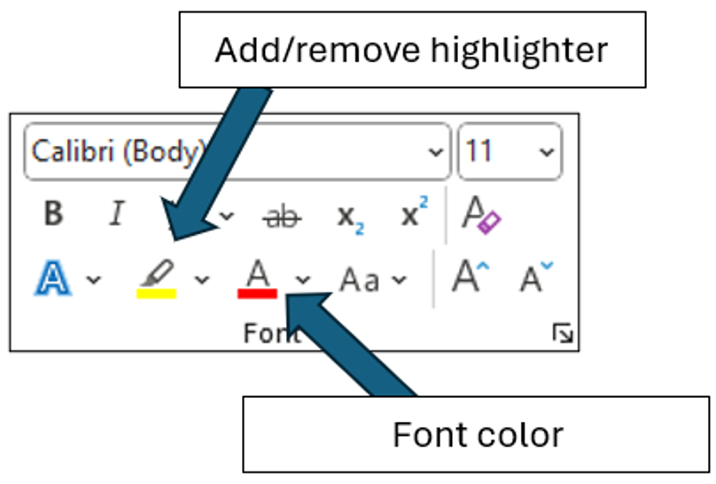

You’ll also see “Check your understanding” boxes throughout the template. These help you think through how to customize certain sections. After you’ve read and completed each one, simply right-click the box and select “Cut.”
Disclaimer. This sample safety program template cannot be used as is. You must customize the template to meet the needs of your organization. EMC does not guarantee that this template is or can be relied on for compliance with any law or regulation, assurance against preventable losses, or freedom from legal liability. We make no representations or warranties of any kind whatsoever, either express or implied, in connection with the use of this template. EMC will not be liable for your use of the template as customized by you. All safety programs and policies, including this template and the information you supply to complete it, should be reviewed by your legal counsel and/or risk management staff.
<COMPANY NAME>
Slip, Trip and Fall Prevention Program

Check Your Understanding. Workplaces are required by the Occupational Safety and Health Administration (OSHA) to provide a workplace free from recognized hazards that are causing or are likely to cause death or serious physical harm. This includes preventing slips, trips and falls. Specific requirements can be found in 29 CFR 1910.22 and 1926 Subpart M. While a single written Slip, Trip and Fall Prevention Program is not mandated for all workplaces, slip, trip and fall hazards must be actively managed, and having a written program will help in these efforts. A well-developed Slip, Trip and Fall Prevention Program and employee training can result in fewer and less severe injuries.

Revision History
<Revision 1 – August 2025>
Purpose
The purpose of <Company Name’s> Slip, Trip and Fall Prevention Program is to reduce the number and severity of slip, trip and fall injuries to all those who may come onto the premises.

Our proactive slip, trip and fall prevention approach focuses on correcting walking/working surface hazards that have been identified, developing a systematic approach to identify and correct new hazards as they arise, as well as addressing employee behavior that may contribute to slip, trip and fall accidents.

All employees are required to follow the procedures outlined in this Program. Any deviations from this Program must be immediately brought to the attention of your supervisor or the Program Administrator.

Scope
<Company Name> strives to provide all employees and on-site visitors with safe walking surfaces. This program is integrated into our company’s written safety and health program and is a collaborative effort that includes all employees. The Slip, Trip and Fall Prevention Program Administrator is responsible for the Program’s implementation, management, training and recordkeeping requirements.

Program Responsibilities
Management. The management of <Company Name> is committed to slip, trip and fall prevention. Management supports the efforts of the Slip, Trip and Fall Prevention Program Administrator by pledging financial and leadership support for the identification and control of walking/working surface risk factors. Management supports an effective walking/working surface hazard reporting system and will respond promptly to reports. Management will regularly communicate with employees about the program.
Slip, Trip and Fall Prevention Program Administrator. The Program Administrator, <Name (Phone Number)>, reports directly to upper management and is responsible for this program. All evaluations, controls and training are coordinated under the direction of the Program Administrator in collaboration with management and employees. The Program Administrator will monitor the results of the program to determine additional areas of focus as needed. The Program Administrator will also:
- Ensure evaluators performing walking/working surface evaluations are properly trained
- Ensure control measures are implemented in a timely manner
- Ensure a system is in place for employees to report walking/working surface hazards to managers and supervisors
- Ensure accurate records are maintained and provide documentation upon request
- Schedule manager, supervisor and employee training and maintain training records
- Follow up with any slip, trip and fall prevention strategies and/or solutions
- Monitor the Program on a quarterly basis and provide an annual review
Managers and Supervisors. Managers and supervisors of <Company Name> will:
- Remain accountable for the health and safety of all employees within their departments through the active support of the Slip, Trip and Fall Prevention Program
- Attend slip, trip and fall prevention training to familiarize themselves with the elements of the Program, recognition and control of walking/working surface hazards and best practices to prevent slip, trip and fall accidents
- Ensure employees in their areas have received the appropriate training, including awareness training addressing behavioral risk factors that may lead to slip, trip and fall incidents
- Ensure slip, trip and fall prevention practices and principles are considered when renovating or expanding facilities
- Ensure that recommended controls are implemented and/or used appropriately through active follow-up
- Provide employees with and ensure the use of the appropriate tools, equipment and materials in accordance with slip, trip and fall prevention best practices
- Maintain clear communication with managers and supervisors
Employees. Employees of <Company Name> are responsible for conducting themselves in accordance with this Program. All employees will:
- Use the appropriate tools, equipment, materials, procedures and designated footwear in the manner established by this Program and their managers and supervisors
- Provide feedback to managers and supervisors regarding the effectiveness of walking/working surface hazard mitigation, new tools, materials or equipment or other interventions
- Attend slip, trip and fall prevention training as required and apply the knowledge and skills acquired to actual jobs and work activities
- Use the proper <Slip/Trip/Fall Hazard Report (Appendix A)> to report walking/working surface hazards to their manager, supervisor or the Program Administrator as soon as possible
- Report all injuries within 24 hours of their occurrence
Employee involvement is an essential element to the success of this program. Employees are encouraged to provide their input and assistance with identifying walking/working surface hazards, development and implementation of controls and training. Employee participation in the Program will occur only during company time.
Check Your Understanding. A mechanism or methodology should be provided which is easily accessible to employees to enable quick reporting of any walking/working surface hazards. While a sample Slip/Trip/Fall Hazard Report is provided, this could be replaced with an online reporting system, an app, or other means your workplace might use. Training on how to report and where to find the reporting forms or system should be covered with all employees.

Walking/Working Surface Safety Program
Floor Selection. All floors when modified or replaced will provide “high traction” as defined by ANSI B101.5. Floors that cannot be modified to “high traction” status must be reviewed and approved by the Program Administrator and be documented and monitored.
Check Your Understanding. There are three ranges of floor safety pertaining to traction. Floor products are required to be labeled with their level of traction. This should be done with markings and symbols. While coefficient of friction (COF) readings are cited as decimal values, the symbol graphic uses whole numbers ranging from 1 to 10. Manufacturers have been instructed to multiply their product’s COF test result values by 10. Product symbols may be black and white or colored. The three ranges may be described as:

- < 0.40 COF - minimal traction, immediate attention is needed
0.40 – 0.60 COF - moderate traction, monitor and maintain cleanliness, consider traction-enhancing
products and practices
> 0.60 COF - high traction, considered a safe walking surface
- 1 thru 4 (low traction)
5 thru 6 (moderate traction)
7 thru 10 (high traction)
- Red (low traction)
Yellow (moderate traction)
Green (high traction)
With wear, cleaning, spills, grease, and other conditions affecting the flooring surface, the COF may lessen over time and should be periodically checked. The COF readings should be taken on a wet surface.

Walking/Working Surface Audits. All walking and working surfaces will be formally audited every other month using the proper audit forms located in Appendix B of this program. Managers, supervisors and employees should be observant of possible slip, trip and fall hazards at all times. Any observed hazards should be immediately reported to managers, supervisors or the Program Administrator.

Floor Cleaning. All floors will be maintained to reduce slip, trip and fall hazards and meet requirements of ANSI B101.0 and B101.1.
- Only Program Administrator-approved cleaning materials will be used on walking and working surfaces (see table below)
- The manufacturer’s instruction will be followed at all times on approved cleaning materials
- A dry extraction cleaning method will be used on all appropriate surfaces
- All spills (liquid or other materials that would reduce traction) will be cleaned up immediately. If cleanup cannot occur immediately, the spill area will be blocked off to keep employees from walking on the spilled material and the area will be marked with a wet floor sign. The barricade and wet floor sign will be removed when the floor is dry. Wet floor signs can be obtained from <Location> or by contacting <Name, Program Administrator, Phone Number>
Type of Floor | Location | Cleaning Product and Procedures
<Terrazzo, vinyl tile, concrete> | <add> | <add>

Walking/Working Surface Maintenance. All walking/working surfaces will be kept free of substantial cracks, changes in elevation greater than ¼ inch, holes, protrusions and unmarked changes in elevation (curbs stairs, etc.).
Check Your Understanding. For additional information, refer to the Slip, Trip and Fall Prevention Guide document from EMC Insurance Companies.

Snow and Ice Management. The maintenance of snow and ice on all walking/working surfaces will be the responsibility of <Name(s), Job Title, Company>. Maintenance of all sidewalks, entrances, loading docks and other areas of heavy foot traffic will begin upon snow accumulation of <½ inch> or more. These areas will be continually maintained as long as snow continues to fall. Parking lot snow maintenance will begin upon accumulation of <2> inches of snow or more. Ice melt will be applied to all sidewalks, entrances, loading docks and other areas of heavy foot traffic upon snow being moved from the surface. Ice melt will also be applied to areas in parking lots where ice buildup is present. When thawing and refreeze is possible, a review of all parking lots and sidewalks will be conducted prior to first shift and ice melt applied as appropriate. All snow moved from parking lots and sidewalks will be removed from the property or piled in approved areas only. Approved snow storage areas are at the <Location, e.g., south end of parking lot>. Written documentation of snow and ice maintenance will be maintained. See Appendix C for a sample maintenance log.
Mats. Entrance mats will be placed at all entrances at all times when there is a possibility of employees and/or visitors tracking in moisture, snow or ice. All entrance mats will be a minimum total of 15 feet in length or will cover the entire entrance path if shorter. Mats will be checked hourly by <Name(s), Job Title> to ensure they are not saturated or damaged. If a mat becomes saturated, it will be replaced immediately or will be vacuumed with a wet/dry shop vacuum until acceptable. Damaged mats will also be replaced.
Check Your Understanding. Entrance mats are designed to provide a slip-resistant walking surface while absorbing contaminants and moisture. They are crucial in helping reduce slippery floor hazards. The most critical area for slip-and-fall prevention in buildings is the first 15 to 20 feet inside the entrance. A comprehensive mat strategy should be developed to ensure that walkways are as safe as possible in all weather conditions. Consider a three-level approach: 1. Outdoor scraper mat, 2. Indoor wiper/scraper mat, 3. Indoor wiper mat.

Footwear. Employees working in areas with limited traction or performing specific jobs will be required to wear slip-resistant footwear or special high-traction equipment. The jobs/tasks where slip-resistant footwear is required are shown in the table below.

Task/Job | Footwear Required
<Maintenance> | <Steel-toed, slip resistant>
<Food Service> | <Slip resistant, closed toe and heel>
<Grounds/Spreading ice melt> | <Ice cleats>
Check Your Understanding. Flat-soled shoes help reduce slips and falls by maximizing the surface area in contact with the floor and minimizing the risk of catching or tripping on a stair tread. For example, shoes with a two-inch raised heel reduce contact with the floor by 40%. For snowy conditions, shoes or boots with hard rubber soles and deep cleats are appropriate. However, they do not perform as well indoors. For icy conditions, strap-on ice cleats provide a better grip. Slip-resistant shoes for wet or oily surfaces feature a multidirectional tread pattern to minimize hydroplaning and a softer rubber sole to help grip hard-surfaced floors. Avoid sandals, flip-flops and shoes with open backs or toes.

Unexpected Changes in Elevation. All unexpected changes in elevation, such as raised sidewalk sections, potholes, raised doorway thresholds or unmarked curb edges will be repaired as soon as possible. Seasonal temperature and weather may affect timing of repairs.
Warning signs or safety cones will be installed to clearly identify hazardous areas for pedestrians until repairs are made. Mud jacking or concrete grinding will be used to level raised concrete sections. Potholes and large gaps between sidewalk sections will be temporarily patched with asphalt. Doorway threshold transition plates will be installed where necessary. All raised edges, including curbs, will be painted with high-visibility, slip-resistant yellow paint.
Wet or Slippery Process Floors. Floors that become and remain wet due to work processes or other reasons will be modified with abrasive coating or grit strips approved by the Program Administrator. They will be applied as necessary to increase traction. The abrasive coatings will be applied according to the manufacturers’ directions. Grit strips will be applied to stair treads, ramps, vehicle running boards and areas around equipment.

Responding to a Slip, Trip or Fall
If a slip, trip or fall occurs on <Company Name> property, follow these steps:
- Offer assistance
- Provide first aid if necessary
- Call 911 if necessary
- Report the incident as soon as possible to the Program Administrator
- Complete the Slip, Trip and Fall Incident Report (Appendix D) as soon as possible
- Give the signed form to the Program Administrator
- Keep a copy of all incident reports
- Review the report to identify the root cause of the slip, trip or fall
- Correct the identified problems
- Provide a copy of the report to your insurance company

Employee Training
Training in the recognition and control of slip, trip and fall hazards and safe work practices will be given as follows:
- To all new employees during orientation
- To all employees annually

The minimum training for all managers, supervisors and employees will include the following elements:
- An explanation of <Company Name’s> Slip, Trip and Fall Prevention Program and their role in the Program
- A description of slip, trip and fall hazards and unsafe work practices that may contribute to slip, trip and fall accidents
- The importance of reporting hazards to management and the forms and process for reporting and investigating slip, trip and fall hazards
- The methods used by <Company Name> to minimize slip, trip and fall risk factors (including engineering controls, administrative controls and any appropriate personal protective equipment or footwear)
- The procedures for responding to a slip, trip or fall
- Proper use of wet floor signage

All training will be recorded on the Employee Training Record Form located in Appendix E.

Periodic Program Review
At least annually, the Program Administrator will conduct a program review to assess the progress and success of the program. The review will consider the following:
- Evaluation of all training programs and records
- The need for retraining of managers, supervisors and employees
- The jobs, processes or areas that have produced a high incidence rate of slip, trip and fall accidents
- Responsiveness in correcting reported slip, trip and fall hazards
An annual review report will be submitted to management using the form in Appendix F.

Record Retention
<Company Name> will maintain the Slip, Trip and Fall Prevention training records, hazard reports, incident reports, and annual evaluations for <5> years.

Check Your Understanding. Record retention periods vary based on the type of record, but typically, the minimum length is 5 years. Your company will need to determine the time period for record retention.

Appendix A – Slip/Trip/Fall Hazard Report

Employee Information

Employee Name:

Job/Title:

Department:

Supervisor:

Describe hazardous condition or areas of concern:

Employee Signature:

Date Submitted:

Program Administrator Response

Date evaluation is scheduled:

Hazard evaluated by:

Evaluator’s Assessment:

Follow-up Action Plan:

Evaluator’s Signature:

Date of Evaluation:
Appendix B – Slip/Trip/Fall Prevention Audit Checklists
Indoor Walking Surfaces
Building/Area Evaluated: | Date of Evaluation:
“NO” responses indicate areas which should be investigated. | Yes | No
Are walkways free of low-lying objects, especially at blind corners?
Are floor tiles in good condition with no broken or missing tiles?
Are grouted floor tiles smooth and even with no lippage > 1/16”?
Are doorway thresholds beveled and no more than 1/4” high?
Is carpeting free of ripples, tears and humps?
Are stair nosings in good condition?
Do stair nosings have edge treatments or highlighting to increase visibility?
Is lighting in stairwells adequate?
Are steps in low-light areas, like auditoriums, illuminated at ground level?
Are utility or drain covers in good condition and even with walkways?
Are cords and hoses routed away from walkways?
Are cord covers or tape used whenever cords are placed along walkways?
Are good housekeeping practices followed, and are they effective in maintaining walkways in an open and clear condition?
Are walkways free of liquids, oils or other contaminants that could create a slippery condition?
Have detailed floor maintenance procedures been documented and communicated to employees?
Have floor maintenance procedures and cleaners been examined to ensure their use does not create hazardous, low-traction walking surfaces?
Are wet floor signs used appropriately and not placed so as to create a trip hazard?
Are wet process work areas treated with traction strips, anti-slip coatings or mats designed for wet processes?
Are mats adequate to prevent water and soil from being tracked inside?
Are mats in good condition, able to clean shoes/boots and absorb water?
“NO” responses indicate areas which should be investigated. | Yes | No
Are indoor mats replaced as needed or dried with a wet vacuum during the day to prevent snow/water infiltration?
Do mats have slip-resistant backings and lie flat with minimal buckling?

Outdoor Walking Surfaces
Building/Area Evaluated: | Date of Evaluation:
“NO” responses indicate areas which should be investigated. | Yes | No
Are parking areas free of potholes, depressions or damaged/uneven surfacing?
Are curbs in good condition with an even transition to sidewalk?
Are wheel stops, curbs, crosswalks and speed bumps well-marked?
Is slip-resistant paint used for all pavement markings?
Are wheel stops situated to prevent vehicles from infringing upon walkways?
Is there adequate lighting in parking areas and along walkways?
Are sidewalks and walkways smooth and even (no raised edges > 1/4”)?
Is the ground surface directly next to sidewalks relatively level and free from hidden drop-offs or holes?
Are walkways free of cords, hoses, large grate openings or other tripping hazards?
Are open, unpaved and/or grassy areas that are expected to be walked on free of holes and low-lying objects like sprinkler heads and valves?
Are downspouts and drains oriented to prevent discharge onto walkways?
Are walkways that are subject to wet or icy conditions coated or designed with a rough, textured finish?
Are handrails present and in good condition on stairs and ramps?
Are ramps constructed with slip-resistant materials or treated with traction strips?

Snow/Ice Management
Building/Area Evaluated: | Date of Evaluation:
“NO” responses indicate areas which should be investigated. | Yes | No
If using a snow/ice management contractor, are detailed contracts in place?
If there is a contract, does it specify weather triggers and expectations during thaw/refreeze conditions?
Are walkways and parking areas cleared before people arrive in the morning?
Are walkways and entrances shoveled throughout the day during snowy conditions?
Are ice control products applied to effectively manage slip hazards on walkways, especially on north sides of buildings?
Is black ice controlled with ice melt, sand, oil absorbent compound and/or warning cones?
Is snow piled so as to minimize thaw/refreeze problems?
Notes:

Appendix C – Snow and Ice Maintenance Documentation Checklist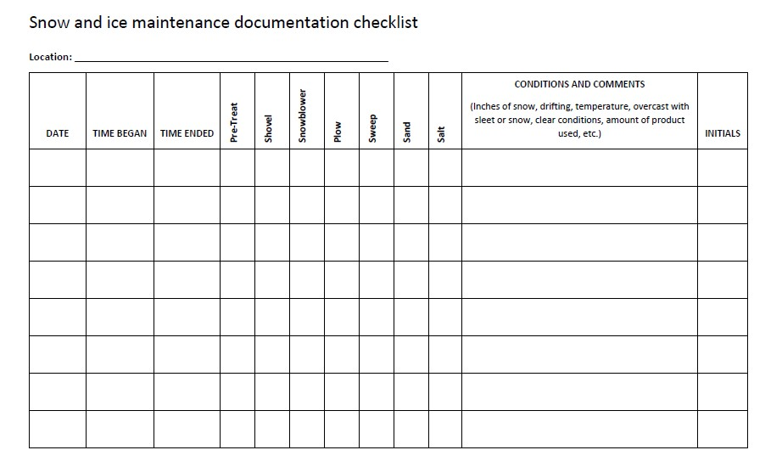
Appendix D – Slip, Trip and Fall Incident Report

SLIP, TRIP AND FALL INCIDENT REPORT
Location #: _________________________ Location name: _______________________________________________
INCIDENT INFORMATION
Date: ________________ Day of week: _________________________ Time: __________ ☒ AM ☐ PM
Location of incident: ________________________________________________________________________________
Description of incident: ______________________________________________________________________________
__________________________________________________________________________________________________
__________________________________________________________________________________________________
Weather conditions: ________________________________________________________________________________
Walking surface conditions: __________________________________________________________________________
Incident reported when it occurred? ☐ Yes ☐ No
If no, how was it reported and when? ___________________________________________________________________
__________________________________________________________________________________________________
__________________________________________________________________________________________________
CLAIMANT INFORMATION
Last name: _____________________________________ First name: ______________________________________
Age: ________ Sex: ☐ Male ☐ Female If minor, was child supervised? ☐ Yes ☐ No
If no, explain: ______________________________________________________________________________________
__________________________________________________________________________________________________
Address: __________________________________________________________________________________________
Telephone: Home: (______) ______-__________ Business: (______) ______-__________
Why was claimant in the facility? ______________________________________________________________________
__________________________________________________________________________________________________
What was claimant doing prior to the incident? ___________________________________________________________
__________________________________________________________________________________________________
Type and condition of footwear: _______________________________________________________________________
BODILY INJURY
Description of injury: ________________________________________________________________________________
Treatment given (if any): _____________________________________________________________________________
__________________________________________________________________________________________________
Was the injured person taken to medical facility? ☐ Yes ☐ No
If yes, where? ______________________________________________________________________________________
How was he or she transported? (name of agency) ________________________________________________________
Name of attendant: _________________________________________________________________________________
WITNESSES
Name: ______________________________ Address: _____________________________________________________
Phone: ______________________________ Comments: __________________________________________________
__________________________________________________________________________________________________
Name: ______________________________ Address: _____________________________________________________
Phone: ______________________________ Comments: __________________________________________________
__________________________________________________________________________________________________
INVESTIGATION
Was incident site inspected immediately? ☐ Yes ☐ No Time: ____________________ ☐ AM ☐ PM
Inspected by: ______________________________________________________________________________________
How did we find out about the incident? ________________________________________________________________
__________________________________________________________________________________________________
Describe conditions at scene: _________________________________________________________________________
__________________________________________________________________________________________________
Describe lighting conditions: __________________________________________________________________________
__________________________________________________________________________________________________
Was photograph taken of accident scene? ☐ Yes ☐ No
Were floor mats in place? ☐ Yes ☐ No
Condition of mats: __________________________________________________________________________________
If floor was wet, were Caution signs in place? ☐ Yes ☐ No
Eyeglasses being worn? ☐ Yes ☐ No If yes, type: __________________________________________________
Cane or walker used? ☐ Yes ☐ No If yes, why? ____________________________________________________
Was injured taking medication? ☐ Yes ☐ No If yes, why? ___________________________________________
__________________________________________________________________________________________________
NOTE: Include a copy of the daily floor check log for the date of the accident

ADDITIONAL INFORMATION
__________________________________________________________________________________________________
__________________________________________________________________________________________________
__________________________________________________________________________________________________
__________________________________________________________________________________________________
Additional paperwork attached? ☐ Yes ☐ No If yes, describe: ________________________________________
__________________________________________________________________________________________________
SIGNATURES

Report completed by: _______________________________ Signature: ______________________________________
Date completed: ____________________ Read and approved by: ___________________________________________
Disclaimer: This material is designed and intended as general information only. This form was not drafted by an attorney and is not intended, nor shall be construed or relied upon, as specific legal advice.
Appendix E – Training Record/Certification for Slip, Trip and Fall Prevention

The following individuals received training on the Slip, Trip and Fall Prevention Program.

Print Name | Sign Name

Print Instructor’s Name
Instructor’s Title
Instructor’s Signature
Date of Training
Appendix F – Annual Evaluation Report

Date of Evaluation:

Evaluated by (list all present):

Written Program Reviewed: ☐ Yes ☐ No

Do injury records indicate a need for additional employee training on the slip, trip and fall prevention program?
☐ Yes ☐ No

Have any jobs, processes or areas produced a high incidence of slip, trip and fall incidents? ☐ Yes ☐ No

If yes, what corrective action is needed?

The following content was added/modified/removed from the written program:

Comments:

