Using this template

This guide is designed to help your organization build a written safety program.

You’ll need to customize the template to fit your organization—it’s not ready to use as is. We’ve made that process easier by adding visual prompts throughout the document. Look for yellow-highlighted, red text that shows where you need to add or update information.

You can (and should) change any part of the template to match your organization’s structure, such as department names, job titles, responsibilities, or procedures.

Example
Before:
<COMPANY NAME>
Sample Safety Program

After:
XYZ Company
XYZ Safety Program

Formatting tips
- To remove the yellow highlighting: Select the highlighted text, then click the highlighter icon in the Font menu.
- To change the red font to black: Select the text and click the font color icon.
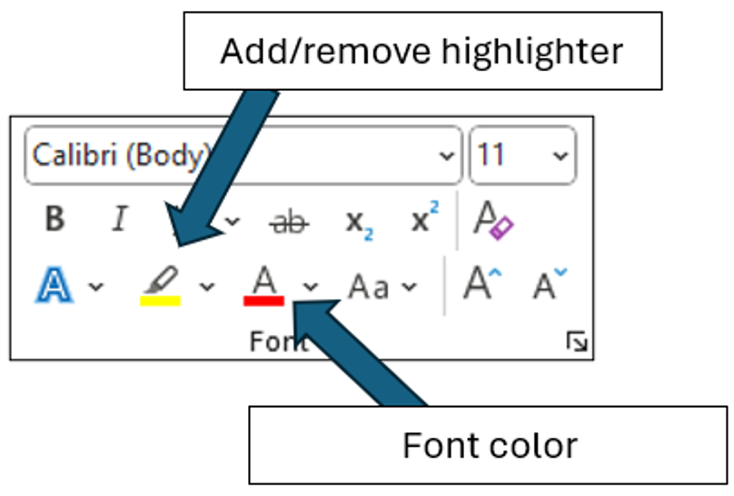

You’ll also see “Check your understanding” boxes throughout the template. These help you think through how to customize certain sections. After you’ve read and completed each one, simply right-click the box and select “Cut.”
Disclaimer. This sample safety program template cannot be used as is. You must customize the template to meet the needs of your organization. EMC does not guarantee that this template is or can be relied on for compliance with any law or regulation, assurance against preventable losses, or freedom from legal liability. We make no representations or warranties of any kind whatsoever, either express or implied, in connection with the use of this template. EMC will not be liable for your use of the template as customized by you. All safety programs and policies, including this template and the information you supply to complete it, should be reviewed by your legal counsel and/or risk management staff.
Generic organization
Hazard Communication Program
Purpose
Generic organization is committed to preventing chemical exposures that may result in injury and/or illness. The purpose of this program is to make sure that all affected employees understand the dangers of all known hazardous chemicals used by Generic organization, and to protect company employees who may come in contact with hazardous chemicals while performing their job duties.

Scope

Generic organization strives to provide all employees and on-site contractors with a safe and healthy workplace. This Hazard Communication Program is integrated into our company’s written safety and health program, and is a collaborative effort that includes all employees. This safety program affects all company employees who may come in contact with hazardous chemicals while performing their job duties. Any deviations from this program must be immediately brought to the attention of the Program Administrator.

Exclusions from this program:
- Foods, drugs, cosmetics or tobacco products intended for personal consumption by the employees while in the workplace
- Any consumer products or food packaged for distribution to (and intended for use by) the general public

Program Responsibilities
Management. The management of Generic organization understands the importance of informing employees of the chemical hazards in the workplace. Management supports the efforts of the Program Administrator by pledging financial and leadership support for the program. Management will regularly communicate with employees about the program.
Hazard Communication Program Administrator. The Program Administrator is Unknown Person and is responsible for the program’s implementation, management and recordkeeping requirements. The Program Administrator will report directly to upper management and be responsible for this policy and program. All safety data sheet (SDS) evaluations, implemented control measures for chemical handling, PPE requirements and training will be coordinated under the direction of the Program Administrator in collaboration with management. The Program Administrator will monitor the results of the program to determine if additional areas of focus are needed. The Program Administrator will also:
- Develop a list of all hazardous chemicals in the workplace
- Obtain SDS for all hazardous chemicals on-site (sample found in Appendix A)
- Complete a chemical hazard assessment for all hazardous chemicals
- Determine the appropriate PPE for all work tasks involving chemicals
- Obtain and review SDS for new chemicals prior to using the chemical
- Identify where and how all SDS are stored
- Ensure annual training is performed and documented (Appendix B)
- Verify that all contractors have a Hazard Communication Program
- Provide contractors with the hazard communication information necessary to safely complete their tasks
- Conduct an annual review of the Hazard Communication Program and document the review(Appendix C)
Managers and Supervisors. Managers and supervisors will:
- Be accountable for the health and safety of all employees within their departments and actively support the Hazard Communication Program
- Attend annual training on the program
- Verify that employees in their areas have received appropriate training
- Ensure that recommended controls are implemented and/or used appropriately
- Notify the Program Administrator when new hazardous chemicals are purchased
- Notify the Program Administrator when new employees are hired
Employees. Every employee is responsible for conducting himself/herself in accordance with this policy and program. All employees will:
- Attend hazard communication training as required and apply the knowledge and skills acquired to all work activities
- Become familiar with chemical label information, including pictograms
- Become familiar with the 16 sections of SDS
- Use appropriate PPE for the chemicals and tasks being performed

Chemical Inventory List
Generic organization maintains a list of the hazardous chemicals currently present in the workplace (see below). This list is periodically reviewed and updated by the Program Administrator. The list is cross-referenced with the SDS.
Chemical Name | Manufacturer | Location Used | SDS (Y/N)

Safety Data Sheets (SDS)
Safety data sheets provide detailed information on each hazardous chemical, including its potentially hazardous effects, its physical and chemical characteristics and recommendations for appropriate protective measures.
The Program Administrator obtains the necessary SDS for all hazardous materials. SDS are kept at location of SDS, and are available to all employees on all shifts who wish to review them or need them for emergency information.
Employees who require emergency medical treatment after exposure to a chemical should take a copy of the SDS to the medical facility.
Container Labeling

The chemical manufacturer, importer or supplier is responsible for labeling the chemical containers received by Generic organization. Employees receiving chemical shipments are responsible for ensuring the chemical containers are labeled. If the chemical containers are not labeled or if the label is damaged, contact the Program Administrator. Chemicals transferred to secondary containers in the workplace must also be appropriately labeled.

The procedures for proper labeling of all containers are as follows:
- Inspect incoming containers to ensure they have legible labels
- Manufacturer chemical labels should never be removed or defaced until the chemical is completely used; Empty containers that are saved for reuse must have the original label removed or covered
- Empty containers that are used for waste or chemical products must have a new label or have the information written directly on the container
- Secondary containers must be labeled with the chemical name and hazard when the substance is transferred from the primary container to a secondary container
- All chemical storage areas such as cabinets, shelves and refrigerators must be labeled to identify the hazardous nature of the chemicals stored within the area (e.g., flammables, corrosives, oxidizers, etc.). All signs should be legible and easily seen

Generic organization will use labels identical to those supplied by the manufacturer, importer or supplier for all secondary containers used. No containers or chemicals will be used if not properly labeled. If there is a question about the accuracy of the label or if a container is not labeled, contact the Program Administrator immediately. (See label example in Appendix A)

Employee Training
Generic organization provides employees with information on any operations in their work area(s) where hazardous chemicals are present, the location of the written Hazard Communication Program, chemical listings and the location of SDS. Training will be provided on the job and in a classroom setting prior to first exposure to a hazardous material, and will cover the specific chemicals the employee is exposed to and their associated hazards. Chemical-specific information will always be available through labels and SDS. Attendance at all training is mandatory. Refresher training will be conducted at least annually.
Employee training will cover the following items:
- Any operation in their work area(s) where hazardous chemicals are present
- The location and availability of the written Hazard Communication Program, including the required list(s) of hazardous chemicals, labels and SDS
- Methods and observations that may be used to detect the presence or release of a hazardous chemical in the work area(s) (such as monitoring conducted by the employer, continuous monitoring devices, visual appearance or odor of hazardous chemicals when being released, etc.)
- Describe the labeling system, including the signal words, hazard statements, precautionary statements and pictograms. (example label found in Appendix A)
- The physical and health hazards of the chemicals in the work area(s), and where this information can be found on the chemical label and SDS
- The measures employees should take to protect themselves from these hazards, including specific procedures the employer has implemented to protect employees from exposure to hazardous chemicals, such as appropriate work practices, emergency procedures and use of personal protective equipment
- The details of the Hazard Communication Program, including an explanation of the SDS, and how employees can obtain and use the hazard information
- The periodic requirement for employees to perform non-routine tasks that may involve hazardous materials and the information given to them before starting work by their supervisor regarding the potential exposure hazards
Training will also be provided on an as-needed basis when new hazards are introduced into the workplace, when new hazards are discovered, and/or when new information on a SDS has been revised. All training will be documented on the employee training form (Appendix B) and retained by the Program Administrator.
Informing Contractors
Generic organization provides contractors and other employees with information about hazardous chemicals their workers may be exposed to while working at Generic organization. The Program Administrator will be responsible for obtaining information about hazardous chemicals used by others to which our employees may be exposed.
The Program Administrator will provide the following information:
- The location and availability of the written Hazard Communication Program, including the required list(s) of hazardous chemicals, labels and SDS
- Inform the contractors and other employees of Generic organizations labeling system, including the signal words, hazard statements, precautionary statements and pictograms. (example label found in Appendix A)
- The measures contractors and other employees should take to protect themselves from these hazards, including specific procedures Generic organization has implemented to protect employees from exposure to hazardous chemicals, such as appropriate work practices, emergency procedures and use of personal protective equipment

Periodic Program Review
All hazard communication procedures and training are reviewed by the Program Administrator annually.
Annual inspections are documented with the form shown in Appendix C and maintained by the Program Administrator.
Record Retention
All hazard communication training and program review records will be retained for ten years.
All SDS will be archived and retained indefinitely.

Revision History
Revision 1 – 5/1/2025
Appendix A – Label Example
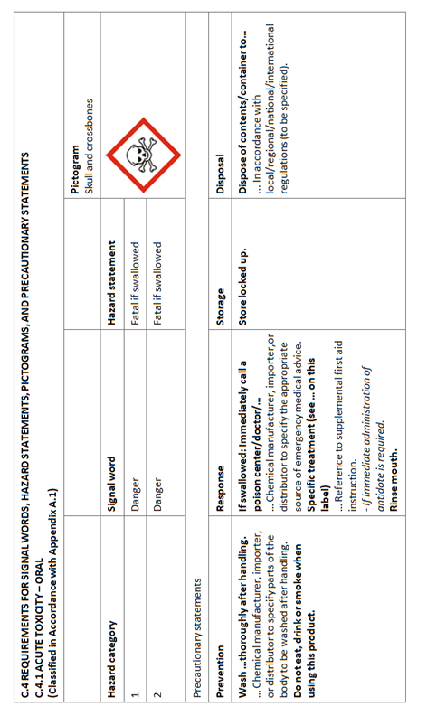
Appendix B – Employee Training Record
The following individuals received training on Steven's test organization Hazard Communication Program.

Print Name | Sign Name | Date

Print Instructor’s Name
Instructor’s Signature
Instructor’s Title
Date of Training
Appendix C – Annual Evaluation Report
Date of Evaluation: | Evaluated by (list all present):
Written Program Reviewed: Yes No
Comments on Written Program:
The following specific chemical handling procedures have been reviewed:
The following specific chemical handling procedures were modified:
The following specific chemical handling procedures were added:
A review of the chemical inventory was made: Yes No

