Using this template

This guide is designed to help your organization build a written safety program.

You’ll need to customize the template to fit your organization—it’s not ready to use as is. We’ve made that process easier by adding visual prompts throughout the document. Look for yellow-highlighted, red text that shows where you need to add or update information.

You can (and should) change any part of the template to match your organization’s structure, such as department names, job titles, responsibilities, or procedures.

Example
Before:
<COMPANY NAME>
Sample Safety Program

After:
XYZ Company
XYZ Safety Program

Formatting tips
- To remove the yellow highlighting: Select the highlighted text, then click the highlighter icon in the Font menu.
- To change the red font to black: Select the text and click the font color icon.
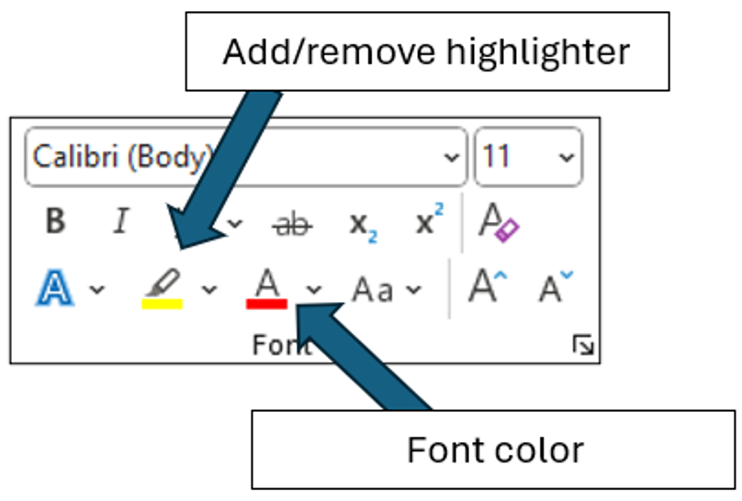

You’ll also see “Check your understanding” boxes throughout the template. These help you think through how to customize certain sections. After you’ve read and completed each one, simply right-click the box and select “Cut.”
Disclaimer. This sample safety program template cannot be used as is. You must customize the template to meet the needs of your organization. EMC does not guarantee that this template is or can be relied on for compliance with any law or regulation, assurance against preventable losses, or freedom from legal liability. We make no representations or warranties of any kind whatsoever, either express or implied, in connection with the use of this template. EMC will not be liable for your use of the template as customized by you. All safety programs and policies, including this template and the information you supply to complete it, should be reviewed by your legal counsel and/or risk management staff.

<COMPANY NAME>
School Fleet Safety Program

Scope

The objective of this program is to reduce or eliminate motor vehicle accidents and associated injuries by following the safe practices established in this program. This program is integrated into the school district’s written safety and health program and is a collaborative effort that includes all employees.

Compliance with this program is mandatory for all school staff who drive vehicles for school business. Violations of this program may result in disciplinary action up to and including suspension of driving privileges or termination.
This Policy does not include additional state or local regulations that apply to school bus drivers.

Program Responsibilities

Management. <COMPANY NAME> is responsible for providing the tools and resources necessary to implement this program and for ensuring that the provisions in this program are being followed by the Program Administrator and all employees.

Program Administrator. The Program Administrator is responsible for the following:
- Evaluating prospective drivers
- Maintaining an accurate qualified drivers list
- Maintaining accurate qualification records
- Maintaining accurate substance abuse testing records
- Ensuring school vehicles are maintained
- Selection/procurement of all school vehicles
- Ensuring all qualified drivers are trained in the safe operation of the school district’s vehicles (This should lead to the satisfactory completion of a road test)
- Monitoring drivers to ensure compliance with all elements of this program
- Coaching drivers using telematic data to improve driving habits or develop a driver mentorship program to coach drivers

Managers and Supervisors. Each supervisor, administrator, manager or director shall be directly responsible for the safe operation of all vehicles under his or her supervision and to:
- Provide driving orientation, training, and monitoring activities according to this policy, or arrange such orientation, training, and monitoring activities with Program Administrator.
- Enforce all provisions of this policy as it relates to the fleet drivers under his or her supervision.

Drivers. <COMPANY NAME> staff who drive vehicles for school business are responsible for conducting themselves in accordance with this program. All drivers will:
- Meet all minimum qualification criteria (see below)
- Maintain an acceptable motor vehicle record (MVR)
- Be medically qualified to drive their assigned motor vehicle
- Maintain satisfactory evaluations from the Program Administrator and/or designated trainer
- Receive negative drug/alcohol tests
- Maintain a valid driver’s license appropriate for the vehicle to be driven. Drivers are to have this license in their possession at all times.
- Immediately notify your supervisor when your driver's license has been suspended, revoked or restricted, or in the event of any accidents or if you receive a citation. Failure to do so may result in loss of driving privileges and/or termination of employment with <COMPANY NAME>.

Note: A driver is anyone who may, in the course of their employment, operate a school-owned motor vehicle, a rented/leased motor vehicle, and/or a personal motor vehicle on school business.

Driver Qualification – All Vehicle Types

<COMPANY NAME> will check the Motor Vehicle Record (MVR) of all driver applicants before they are granted driving privileges and obtain updated MVRs for all approved drivers annually thereafter. All annual reviews will be documented using the form in Appendix H. MVRs will also be checked whenever an employee is involved in a motor vehicle accident. A driver list is maintained and updated annually and includes the last date of an MVR check for each driver. The approved drivers list will be recorded on the form found in Appendix C and maintained by the Program Administrator.
All <COMPANY NAME> employees whose job requires them to drive a school fleet vehicle shall meet the following criteria:
- At least twenty-one years of age
- At least three years of licensed driving experience
- Valid driver’s license appropriate for the vehicle to be driven
- Satisfactory MVR review
- Has not been convicted of any of the following violations within the previous five years:
  - Driving under the influence of alcohol and/or drugs
  - Open container violations
  - Reckless driving
  - Speeding 15 mph over the posted speed limit
  - Vehicular manslaughter
  - Using a vehicle to commit a felony
  - Hit and run/Leaving the scene of an accident
  - Fleeing/eluding police or resisting arrest
  - Operating a vehicle with a suspended or revoked license
  - Passing a stopped school bus
  - Railroad crossing violation
- Has not experienced any of the following within the previous three years:
  - Two “at fault” accidents
  - Three moving violations
  - Two moving violations and one “at fault” accident
  - Tested positive for drugs or alcohol while employed by the district
- All new employees whose job description includes driving a vehicle shall complete the <COMPANY NAME> new driver orientation and training program prior to being added to the approved driver list.
- No employee or non-employee (for example, a student or an employee’s spouse) is allowed to operate a school fleet vehicle unless the Program Administrator has authorized that person to drive.

Additional Qualification Criteria - Bus Drivers

All drivers who are operating a commercial motor vehicle designed to transport more than 16 people are required to possess a valid Commercial Driver's License (CDL) with endorsements appropriate to the vehicle to be driven and as required by the state of Your specific state. Commercial driver applicants will not be considered for employment unless they meet the minimum requirements listed below:
- Possess a current and valid commercial driver’s license or chauffer’s license with passenger and school bus driver endorsements
- Pass all background checks required by local, state and federal guidelines
- Possess a Your specific state school bus operator’s certificate
- Be certified in basic first aid
- Be physically and mentally qualified to drive a school bus, per Your specific state’s CDL manual
- Be able to read and speak English sufficiently to converse with students and the general public, to understand highway traffic signs and signals, to respond to official inquiries and to make entries on reports and logs
- Be able to perform all the tasks and essential duties of their job description
- Have at least two years of verifiable driving experience with like-type vehicles

Driver Training. Upon initial assignment of driving privileges, each driver will be required to attend a training session that outlines the rules and procedures in our Fleet Safety Program. Ongoing training will be offered to all drivers, at least annually, to ensure they are kept up-to-date with defensive driving techniques and changes to the program. Driver ride-a-longs may also be conducted upon initial hire and periodically thereafter as deemed appropriate by the Program Administrator. Training and retraining will be documented by the Program Administrator (Training Record/Certification forms are in Appendix B).
Motor Vehicle Record Review

All employees whose job description includes driving a school fleet vehicle, even occasionally, shall have their MVR reviewed annually. All annual reviews will be documented using the form in Appendix H. Each listed driver must meet the driver qualification criteria listed above.
A driving record (MVR) will be reviewed annually for all school bus drivers according to the legal requirements of the State of Your specific state. Eligibility to operate a school bus will be determined by that review.

All drivers for <COMPANY NAME> are expected to maintain a driving record that reflects good driving habits. Drivers are required to immediately notify their supervisor when their driver's license has been suspended, revoked or restricted, or in the event of any accidents or receipt of any citations. Failure to do so may result in loss of driving privileges and/or termination of employment with <COMPANY NAME>.

Any employee not meeting the <COMPANY NAME> MVR acceptability criteria will be notified that his or her driving privileges have been suspended. If current duties cannot be performed without driving, the employee may be reassigned to an available, non-driving position for which the employee is qualified. If no such position is available, the employee may be terminated.
Any deviations from the above MVR acceptability criteria require the written approval of the <COMPANY NAME> Superintendent.

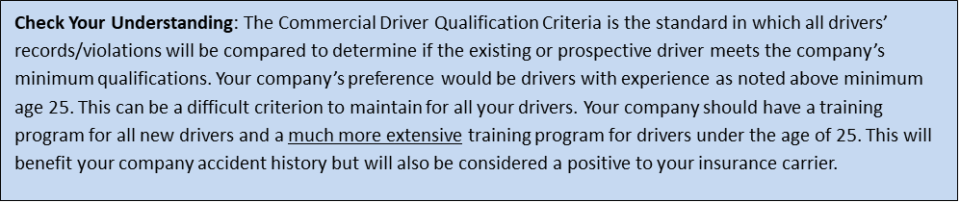

Driver Safety Rules

Drivers must obey all state laws and posted signs when operating vehicles. In addition, the following rules must be followed at all times.
Cell Phones and Other Distractions. The use of handheld or hands-free cell phones or other devices that take attention away from driving are prohibited when driving school vehicles. Passengers may use devices only if the use will not be distracting to the driver. Cell phone calls should be made prior to or at the completion of a trip. If a call must be made during a trip, drivers must pull into a safe location and stop before making the call. If the driver receives an incoming call while driving, they must allow the call to go to voicemail and return the call when stopped in a safe location. Eating while driving is prohibited. Nonalcoholic drinks may be consumed with great discretion and only in situations where driving hazards are minimal (i.e., not in traffic, through road construction, etc.).
Seat Belts. Seat belts must be properly worn by all drivers and passengers while the vehicle is in operation. Children being transported in a school vehicle other than a school bus must remain properly secured in a child safety seat or booster seat according to state law.
Drugs and Alcohol. Drivers will not operate a motor vehicle at any time while under the influence of alcohol, illegal drugs, medication, illness, fatigue or injury. The sale, purchase, transfer or possession of any controlled substance (except medically prescribed drugs) is strictly prohibited while using a school vehicle, while on the school district premises or while engaged in school district business.
Severe Weather. Extreme caution must be exercised when driving in severe weather conditions. If a driver has any doubt about the safety of travel, they must contact their supervisor or the Program Administrator for guidance.
Radar Detectors. The use of radar detectors or any other device with the purpose of detecting or interfering with police radar is prohibited.
Glass. Damaged glass should be reported immediately to the Program Administrator. To reduce windshield damage, drivers will:
- Keep a safe distance between vehicles, especially on gravel roads
- Use clean, greaseless, dry cloths to wipe the windshield
- Replace worn wiper blades as soon as they begin to streak
- Use plastic or rubber ice scrapers, never metal
Towing. Only vehicles specifically approved for towing by the Program Administrator may be used to tow trailers of any size or type.

Accidents and Citations
Traffic citations must be reported to the Program Administrator as soon as possible. The Program Administrator will review the driving privileges of any employee charged with a serious offense. Disciplinary action may include warnings, probation or suspension of driving privileges. For those jobs that require operation of a <COMPANY NAME> fleet vehicle, loss of driving privileges may result in termination.
Vehicle Accident Investigation. Vehicle accident investigations are handled internally and may utilize external documents such as police reports. Vehicle accident reports are to be filled out by the driver and returned to the Program Administrator as soon as reasonably possible. The Program Administrator will determine accident preventability and the proper course of disciplinary action that might be necessary. The Program Administrator will also determine if additional training is needed to prevent similar accidents from occurring in the future. Trends in types of accidents or multiple accidents by the same driver will receive additional scrutiny, as they may signal the need for additional training or changes to driver selection procedures.
When in an accident, drivers must:
- Stop the vehicle and protect the scene to prevent a secondary accident
- Activate flashers
- Call for medical assistance and assist any injured people, if necessary
- Call the police and the Program Administrator or supervisor as soon as possible
- Locate any witnesses and get important information from them. If possible, get names, addresses and phone numbers
- Exchange pertinent information with other drivers
- Take photos of the accident
- Fill out a vehicle accident report form and send it to the Program Administrator (forms are in Appendix D)
- Never admit fault or apologize. Apologies could be interpreted as an admission of fault
- Never argue with other drivers or witnesses
- Never argue with the police
- Never make a statement to the media. Refer them to the Program Administrator
- Never discuss details of the incident with anyone except a representative of <COMPANY NAME> or the police

Additional guidelines for school bus drivers:
- Check for injuries
- Determine if evacuation is necessary. Students should remain on the bus unless conditions are too dangerous
- Evacuate if fuel is spilled, bus is overturned, or fire danger exists
- Radio or call dispatch for help. Stay with vehicle – do not leave to assist other vehicle(s)
- Appoint bus assistant and place triangle reflectors at 10’ and 100’ behind bus, 100’ in front
- Reassure students that the situation is in control
- Follow “Transfer of Students” procedures if necessary
- Follow “Post-Crash” procedures

Note: Every <COMPANY NAME> motor vehicle is required to have a vehicle accident reporting kit in the glove box. This kit should be used by the driver to record accident facts after the accident as soon as feasible. If the vehicle you are driving does not have a Vehicle Accident Report form in it, contact the Program Administrator.

Reporting Vehicle Accident Involving Employee Injury
- Employees injured on the job are to report the injury to the Program Administrator as soon as possible
- The Program Administrator is to follow the established employee injury or accident investigation program

The goal of this reporting and investigation process is not to find fault, but to determine the root cause so that corrective actions can be made in order to prevent future accidents or incidents.

Vehicle Accident Report Retention. Vehicle accident reports and associated information will be maintained by the Program Administrator for three years after the date of the vehicle accident.
The following information will be retained:
- Date of accident
- City and state in which the accident occurred
- Driver name
- Number and nature of injuries
- Copy of vehicle accident report
- Copies of all accident reports required by state or other governmental entities or insurers

Post-Accident Corrective Action Procedure. The Program Administrator will evaluate driver performance after an accident. The corrective actions below will apply if a driver experiences an accident that is judged to be preventable. Accidents will be judged on a case-by-case basis before the corrective action program is initiated.

- A driver who is involved in one preventable accident in six months will be placed on probation for 90 days
- If the driver successfully completes that period of probation without any further accidents, the driver will be taken off the probation list
- If the driver is involved in another preventable accident while on probation, the driver will be subject to further disciplinary action, up to and including termination

<COMPANY NAME> also reserves the right to impose more stringent consequences based on the circumstances and/or severity of a preventable accident.

Vehicle Inspections and Maintenance

To extend the useful life of vehicles, regular inspections and maintenance should be completed on all <COMPANY NAME> vehicles per the manufacturer’s recommendations. If during an inspection any of the items are found to be unsatisfactory the vehicle will be removed from service until it can be repaired or replaced. All problems should be promptly reported to the Program Administrator. Each driver will inspect the vehicle before each use. The inspection will consist of all items listed in the Vehicle Self-Inspection Report (form located in Appendix E). All vehicle Self-Inspection Reports will be submitted to the Program Administrator within one business day.
In states that require emissions testing, all vehicles will comply with the state’s requirements.
Daily Pre-Trip Bus Inspection
All school bus drivers will inspect their bus daily before use. The inspection will consist of all items listed in the Bus Driver’s Daily Pre-Trip Inspection Report (form located in Appendix F). All inspection reports will be submitted to the Program Administrator within one business day.
- Exterior Inspection – Walk around the bus, checking the following items:
- Tires – condition of tread and proper inflation
- Lug nuts
- Windows and light lens covers - condition and cleanliness
- Mirrors – condition and cleanliness, adjusted for driver
- Body damage
- Under bus – loose parts or fluid leaks
- Overall cleanliness
- Wheelchair lift

- Check Lights – Set parking brake, be sure engine is off and then check the following items:
- Headlights (low and high beams)
- Turn signals
- Emergency flashers
- Backup lights
- Brake lights
- Side marker lights

- Check Engine Compartment – After verifying the parking brake is set and/or wheels chocked, the driver will raise the hood and inspect the following items in the engine compartment:
- Fluid levels
- Belts and hoses for cracks or wear
- Belt tension
- Damaged or worn electrical wiring insulation

- Start Engine and Inspect Inside the bus – The driver will verify that the parking brake is set, place gearshift in neutral, start engine and listen for unusual noises. Then check the following:
- Gauges and indicators (oil, ammeter/voltmeter, coolant temperature, engine oil pressure, warning lights)
- Brake pedal height and feel
- Windshield wipers and washer fluid
- Steering – full range of motion and no unusual noises
- Verify the visibility of mirrors and windshield and mirror adjustability
- Check heater and defroster blowers
- Location of emergency equipment, first aid kit and fire extinguisher
- Radio – radio check with dispatch

The driver must also note any other defects that could affect the safe operation of the vehicle or result in its mechanical breakdown. The report must also indicate if no defects are found. The driver must sign and submit the report to the Program Administrator.

The original copy of the inspection report and certification of repairs will be retained in the vehicle maintenance files. The original copies of inspection reports on which defects were noted, and the certification of repairs will be retained for three months.

Additional Guidelines for Commercial Vehicles
<COMPANY NAME> has additional guidelines for our commercial vehicles in addition to all the guidelines listed previously.

Responsibilities.
Program Administrator – In addition to the responsibilities listed above the program administrator must also:
  - Maintaining accurate substance abuse testing records
  - Ensuring all qualified drivers are trained in the safe operation of school vehicles
Drivers -- In addition to the responsibilities listed above the program administrator must also:
  - Be medically qualified to drive a commercial motor vehicle
  - Maintain satisfactory evaluations from the school’s Driver Trainer
  - Receive negative drug/alcohol tests
Driver Trainers -- Driver Trainers of <COMPANY NAME> are responsible for the following:
- Conducting on-road driving tests for new employees and existing employees at least annually
- Making recommendations to the Program Administrator regarding the retention or release of employees based on driving tests

Driver Selection. In addition to the driver selection criteria listed above drivers must also:
- Be able to read and speak English sufficiently to converse with the general public, to understand highway traffic signs and signals, to respond to official inquiries, and to make entries on reports and records
- Be physically and mentally qualified to drive a school vehicle and possess a valid medical certificate as defined in 49 CFR Part 391
- Possess a current and valid commercial driver’s license or chauffer’s license and proper endorsements for the type of commercial vehicle to be driven
- Must not be disqualified to drive a commercial motor vehicle under the rules and regulations set forth in 49 CFR Part 391.15

Hiring Process. When hiring commercial drivers, in addition to the information listed in the Motor Vehicle Record Review section, <COMPANY NAME> will:

Check Previous Employment -- The employment history will be collected and verified for every commercial driver applicant. All commercial driver applicants must provide the following employer information on all driving positions they have held for the previous ten years.
- Names, addresses and phone numbers or other contact information of previous employers
- Names, titles and phone numbers or other contact information of previous supervisors

Check Drug and Alcohol History -- All applicants will be asked if he or she has tested positive, or refused to test, on any pre-employment drug and alcohol test administered by a previous employer. If the employee admits to any of the above, without documented successful completion of DOT return-to-duty requirements, he or she will not be considered for employment.

All applicants who indicate no drug or alcohol violations must provide written consent (Appendix I) for a drug and alcohol history to be obtained for the preceding two years from all DOT-regulated employers. If the applicant fails to provide this consent, he or she will not be considered for employment. Any positive indication of drug or alcohol use at the following levels will immediately disqualify the applicant.
- Alcohol test with a result of 0.04 or higher
- Verified positive drug test
- Verified adulterated or substituted drug test results
- Violations of DOT agency drug and alcohol testing regulations

Individuals who have successfully completed DOT return-to-duty requirements after a drug or alcohol regulation violation will continue through the hiring process.

Conduct Pre-Employment Screening Program – All applicants must provide written approval (Appendix J) for <COMPANY NAME> to request a copy of the applicant’s commercial driving record from the FMCSA’s Pre-Employment Screening Program. Non-compliance with hours of service, cargo securement, vehicle inspections, etc. will be evaluated in the hiring process. Significant or repeated violations may disqualify the applicant.

Conduct Background and Fair Credit Reporting Act Investigations -- All applicants must provide written approval for <COMPANY NAME> to perform a Criminal Background Check and a Credit Report Check (Appendix N and Appendix O). These checks will be made on all commercial driver applicants and other applicants that may be required to operate a motor vehicle while conducting school business.

Conduct Drug/Alcohol Screening -- All commercial driver applicants will submit to a drug/alcohol screening after an initial offer of employment is extended. Only the designated <COMPANY NAME> drug/alcohol testing facility will be used. Drug/alcohol test results from the commercial driver applicant’s previous employer will not be accepted. A negative test result is a condition of employment. No driver applicant will perform any work or activity until a negative test result has been obtained for the driver applicant. Be advised that marijuana remains a drug listed in Schedule I of the Controlled substances Act. It is unacceptable for any employee subject to drug testing under the DOT’s drug testing regulation to use marijuana medicinally or recreationally.

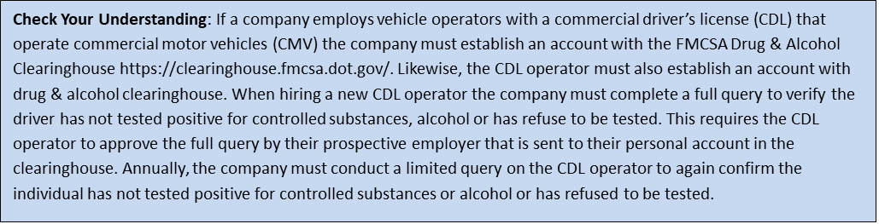

Check Medical Qualification -- All applicants shall be medically examined and certified as physically qualified to operate a commercial motor vehicle by a licensed, DOT-certified medical examiner designated by <COMPANY NAME> .

Conduct Driving Evaluation -- All applicants will be required to submit to a driving test to evaluate their driving proficiency. The driving test will be an on-road driving test with one of <COMPANY NAME>’s Driver Trainers. The applicant will be evaluated on pre-trip inspections, city and rural driving on two-lane and multiple-lane roads including freeway and interstate, passing, backing, and emergency procedures. This evaluation will be used in the hiring assessment and to develop portions of the school district’s mandatory driver training program. This driving test will be completed before a new commercial driver is allowed to operate a commercial vehicle for school business. Driving evaluations will be documented on the Driver’s Road Test Examination form located in Appendix K.

Training for Commercial Drivers.
Individual Driver Training -- <COMPANY NAME> has developed and adopted a policy that all commercial drivers complete a mandatory training period before operating school vehicles. Training is conducted for a minimum of four weeks with a school Driver Trainer and includes both classroom and road training. The total length of the training is dependent on each driver completing all course objectives.

During this training period, the driver is considered a probationary employee. Upon the completion of training, the Driver Trainer will make a recommendation to the Program Administrator to either retain the new driver or release him or her. In some cases, a driver undergoing training may not be allowed to complete the training. This usually occurs if, in the opinion of the Driver Trainer, the driver poses a safety liability to <COMPANY NAME>.

At least annually, a Driver Trainer will ride with each commercial driver to evaluate his or her operation of a commercial motor vehicle. Results will be documented on the Driver’s Road Test Examination form located in Appendix K. The results of this evaluation may indicate a need for additional training with a Driver Trainer. Moving violations and/or accidents may also trigger additional training throughout the year.

Coaching drivers using telematic data. In lieu of vehicle observations telematic data can be used to identify poor driving habits and coach drivers in the manner of how the vehicle should be operated. Telematics identify harsh driving events and Appendix K-1 is used to document the coaching sessions had with each driver. Use Appendix K-1 for regular coaching sessions with the driver and in their annual performance review.

Group Driver Training -- All commercial drivers must attend quarterly and annual training. This training will consist of a review of school procedures, updates on regulatory changes, safety topics such as defensive driving, driver fatigue, discussion of current issues, and a review of all accidents, incidents, and citations. All group training will be documented on the Training Record/Certification Form located in Appendix B.

CSA Program. The Federal Motor Carrier Safety Administration’s Compliance, Safety and Accountability Program (CSA) tracks violations by <COMPANY NAME>’s DOT number. When a driver receives a citation for a moving violation, hours of service, vehicle maintenance or cargo securement, the law enforcement official will check the CSA database to review the safety record of our school district. It is very important that each driver understands how their driving affects not only their safety record, but the district as well.

The Program Administrator will review the CSA safety report each week, and address areas where safety has diminished across the school district. This may result in additional safety training or changes in drivers’ statuses.

Qualification File. As required by the DOT, <COMPANY NAME> maintains a qualification file for all drivers. No employee shall operate a school vehicle, or any vehicle operated while on school business unless they are listed on the school’s Qualified Driver List. This includes personal vehicles if used for school business. <COMPANY NAME> maintains a current list of qualified drivers and is required to provide this list to our insurance carrier annually and anytime changes are made to the list. The Qualified Driver List form can be found in Appendix C. The following information is required for each driver:

- Driver application for employment (Appendix P)
- Copy of driver’s license
- Hire date
- Inquiry To Previous Employers in the past three years (Appendix L)
- Inquiry to State Agencies (Appendix M)
- Medical examiner’s certificate* (medical waiver, if issued)
- Driver’s Road Test Examination results (Appendix K)
- Certificate of road test*
- Annual review of driving record (Appendix H)

*Note: Drivers will be issued copies of these certificates. Drivers only need to have a copy of the medical examiner’s certificate in their possession while driving.

Qualification records for each commercial driver will be maintained for a minimum of five years after the driver’s employment is terminated.

Vehicle Inspections. <COMPANY NAME> is committed to following a rigid, daily inspection program.

Driver Pre-Trip Inspection -- A properly performed and thorough pre-trip inspection will be conducted by each driver prior to operating the vehicle. The following seven steps must be completed for each pre-trip inspection. All vehicle inspections will be documented in the driver’s vehicle inspection report found in Appendix E. If anything, unsafe is discovered during the pre-trip inspection, it must be fixed immediately.

- Review Last Vehicle Inspection Report – The driver must review the last driver’s vehicle inspection report to verify that any needed repairs were made to the vehicle. If an authorized signature certifies that defects were corrected or that correction was unnecessary, the driver will sign the third signature line of the form. If the defects noted were not acknowledged by an authorized signature, the driver shall not drive the vehicle until the defects are corrected.

- Vehicle Documentation – The driver must verify all shipping papers, vehicle registration, insurance cards and any other paperwork required by the DOT are in his or her possession.

- Vehicle Overview – A general condition review of the vehicle is required. The driver will

  - Look for damage or unusual wear to the vehicle. Examples include, vehicle leaning to one side, lights broken or inoperative, tire and rim condition, and suspension and break wear
  - Look under the vehicle for fresh oil, coolant, grease or fuel leaks
  - Perform a walk-around assessment to look for people, other vehicles, objects, low hanging wires or limbs

- Check Engine Compartment – After verifying the parking brake is set and/or wheels chocked, the driver will raise the hood and inspect the engine compartment. Check the following:

- Fluid levels
- Power steering
- Batteries
- Automatic transmission
- Belts for cracks or wear
- Tightness in alternators, water pumps and air compressor
- Cracked, worn electrical wiring insulation

- Start Engine and Inspect Inside the Cab – The driver will verify that the parking brake is set, place gearshift in neutral, start engine and listen for unusual noises. Then check the following:
- Look at gauges (oil, ammeter/voltmeter, coolant temperature, engine oil temperature, warning lights and buzzers)
- The condition of controls. Look for looseness, sticking, damage or improper setting (steering wheel, clutch, accelerator, brake controls [foot brake, trailer brake, parking brake, retarder controls], transmission controls, inter-axle differential lock, horn[s], windshield wiper/washer, and lights [headlights, dimmer switch, turn signal, four-way flashers, clearance, identification, marker light switches])
- The condition of mirrors and windshield/windows
- Location of emergency equipment (three red triangles, properly charged and rated fire extinguisher, tire chains, emergency phone number list and accident reporting kit)

- Check Lights – The driver will make sure parking brake is set, engine is off, and ignition key is out of the switch then check the following items:
- Headlights (low and high beams)
- Emergency flashers
- Parking, clearance, side maker and identification lights
- Turn signals
- Brake lights (a helper will be required to complete this task)

The driver will clean all lights, reflectors, and glass as needed.

- Test Brakes – For hydraulic brakes, the driver will pump the brake pedal three times, then apply firm pressure to the pedal and hold for five seconds. The pedal should not move. For air brakes, verify the slack adjusters do not move more than one inch.

The driver will check the following additional items:
- Brake drums (or disks), linings, and hoses for cracks or other visible damage, appropriate liner thickness and presence of oil or grease
- Check air hoses for worn areas or the presence of cuts or other damage. Shut off the engine and test low pressure warning signal
- Verify spring brakes activate with low air pressure (usually in a range between 20-40 psi)
- Check the rate of air pressure buildup (typically 85-100 psi within 45 seconds in dual air systems)
- Test air pressure leakage (with a fully charged air system typically 125 psi)
- Verify loss rate does not exceed two psi in one minute for single vehicles and three psi in one minute for combination vehicles
- Check air compressor governor cut-in and cut-out pressures
- Test parking brake with transmission in low gear. Test service brake for left or right pulling when service brakes are applied

During a Trip -- Once on the road, the driver must examine his or her vehicle and cargo:
- At each change of duty status
- After driving for 3 hours
- After driving for 250 miles

If a problem is found, the driver must either have the necessary repairs or adjustments made prior to operating the vehicle or safely travel to the nearest repair facility. For vehicles transporting hazardous materials, the driver must examine its tires at the beginning of the trip and each time the vehicle is parked.

During each stop the driver will check the following items:

- Tires, wheels and rims
- Brakes
- Lights and reflectors
- Brake and electrical connections to trailer
- Trailer coupling devices
- Cargo securement devices

Post-Trip Inspection and Report -- Each driver is required to complete a written report on each vehicle’s condition at the end of the day, or when he or she finishes driving the vehicle for that day. Vehicles include power unit and trailer(s). A copy of the inspection form can be found in Appendix E.

The report must be completed in its entirety and the driver must note any defects to following:

- Service brakes including trailer brake connections
- Parking (hand) brake
- Steering mechanism
- Lighting devices and reflectors
- Tires
- Horn
- Windshield wipers
- Rear vision mirrors
- Coupling devices
- Wheels and rims
- Emergency equipment

The driver must also note any other defects that could affect the safe operation of the vehicle or result in its mechanical breakdown. The report must also indicate whether no defects are found. The driver must sign and submit the report to the Program Administrator

The original copy of the inspection report and certification of repairs will be retained in the vehicle maintenance files. The original copies of inspection reports on which defects were noted, and the certification of repairs will be retained for three months.

Vehicle and Equipment Selection.
Vehicle Replacement Schedule –listed here

Vehicles will be replaced regardless of their age or mileage if safety-based repairs cost more than the value of replacement.

The make and model of power units are dictated by a number of factors including, but not limited to, replacement cost, safety features, service availability, warranty, standard features and operating costs.

Safety Features -- All new power units will have the following minimum safety features:

- Disc brakes
- Stability control
- Convex mirrors
- Rear-end avoidance system
- GPS tracking

All single vehicle units will be equipped with rear view cameras.

Cargo Securement.
Cargo securement is extremely important to the safety of the driver, his or her vehicle and other vehicles using the road. Loads should be examined within the first 50 miles of initial transport and again at all following stops. All tie-downs, tarps, doors, hatches, blocks/chocks, straps/chains/binders, tires, placards, lights, etc. are to be verified as secure, meaning they cannot damage the cargo or come loose and fall off the vehicle.

Traffic and Road Reports.
<COMPANY NAME> will work to select the safest delivery routes. The school will use various tools at their disposal to investigate:

- Road conditions
- Heavy traffic
- Road closures
- Dangerous intersections or roads
- Stops near crests of hills, at blind corners or on busy roads
- Tunnels, bridges and overpasses
- Road construction
- Steep grades
- Roads that may have seasonal concerns
- Heavy pedestrian areas

This information will be posted on Location where Notices are posted . The school will also make a computer available in Location where Notices are posted for drivers to investigate road conditions on the route or near their destination. If the road conditions on the driver’s route are hazardous, the driver shall not attempt to drive that route.

Law Enforcement Stops/Roadside Inspections/Weigh Stations.
<COMPANY NAME> expects drivers to behave in a professional and courteous manner when pulled over by law enforcement, going through weigh stations or if asked to participate in a roadside inspection. Directions given by the official should be strictly followed. Failure to comply with the procedures set forth below may result in disciplinary actions up to and including termination.

Roadside Inspection Procedures-- When a driver is required to participate in any of the above actions, he or she must pull off the road immediately to an area designated by the officer. If the driver believes that the designated area is unsafe for the driver and/or the officer, the driver will state his or her concerns to the officer in a courteous and professional manner. Once the inspection is underway, the driver shall follow the directions given by the officer and act appropriately.

The results of all stops and inspection must be reported to the school during the driver’s next scheduled check-in call. The driver must turn in all inspection reports to <COMPANY NAME> upon arrival. If the driver is not scheduled to arrive at a school location within the next 24 hours, the report must be emailed to , <Program Administrator @email address> at <COMPANY NAME>.

If the vehicle or driver is placed out of service, the driver must notify <COMPANY NAME> immediately so can notify the customer of any delays that may result. A vehicle that is placed out of service cannot be operated until all repairs required by the out of service notice have been completed.

Disposition of Report-- Upon receiving a roadside inspection report, <COMPANY NAME> , will make arrangements to correct any defects still outstanding.

The driver will be notified when defects have been corrected. Roadside inspection reports will be analyzed for ways to reduce the number of violations and lower the out of service rate. A copy of the roadside inspection report will be retained for three years.

Periodic Program Review
At least annually, the Program Administrator will conduct a program review to assess the progress and success of the program. The review will consider the following:
- Review current drivers to the list of Qualified Drivers List (Appendix C)
- Evaluation of all training programs and records
- The need for retraining of management and/or drivers based on accident investigation results
- Review the drivers that have a high number of vehicle accidents
- Responsiveness in reporting vehicle accidents
- Vehicle purchases and safety equipment contained on the vehicles
- The program’s success will be determined and reported to senior management using the following criteria:
- Cost and frequency of vehicle accidents
- Employee feedback through direct interviews, audits and questionnaires
- Vehicle accident investigation results
The Annual Review Report Form found in Appendix A will be used for the review.

Records Retention
All records not otherwise identified in this program will be retained for Number of year records are kept years.

Revision History
5/22/2025

Appendix A – Annual Evaluation Report

Date of Evaluation: | Evaluated by (list all present):
Written Program Reviewed: Yes No

Do vehicle accident records indicate a need for additional driver training on the School Fleet Safety program? Yes No

Have any drivers produced a high incidence of vehicle accidents? Yes No
If yes, list:

Is there any record of failure to report vehicle accidents in a timely manner?
If yes, what corrective action is needed?

The following content was added/modified/removed from the written program:
Comments:

Appendix B – Training Record/Certification Document

The following individuals received training on the <COMPANY NAME> Fleet Safety Program.

Print Name | Sign Name

Print Instructor’s Name
Instructor’s Signature
Instructor’s Title
Date of Training
Appendix C – Qualified Driver List

Driver Name | DL # | DL Type | Endorsements | Hire Date | Date Last MVR | Date of Driver Training

Appendix D – Vehicle Accident Report

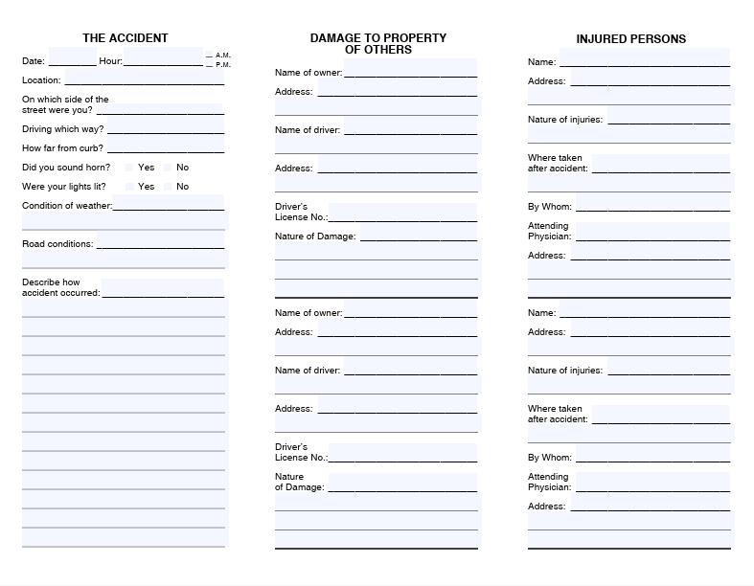

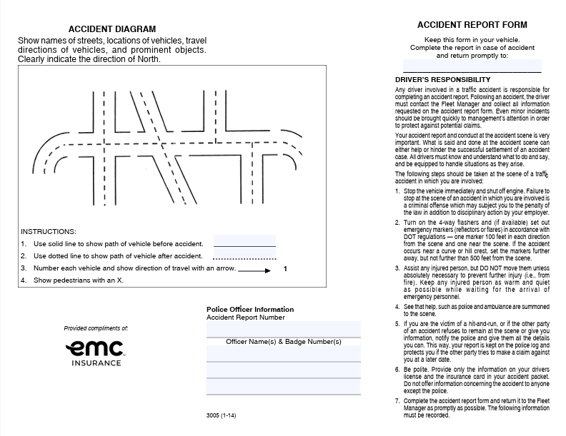

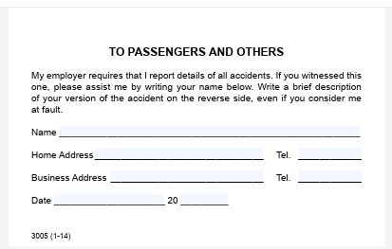

Appendix E –Vehicle Self Inspection Report

If an item is defective, check the box and give details in the remarks section.

Inspection Completed By: |  |  |  |  |  |  |  |  |  |  | Date:
Vehicle Make: |  |  | Model: |  |  | Year: |  |  |  | No.:
Beginning Mileage: |  |  |  |  | Ending Mileage:
Not OK | OK | Before Starting Engine |  |  |  |  | Not OK | OK | After Starting Engine
 |  | Body |  |  |  |  |  |  | Brakes
 |  | Brake/head/tail/clearance lights |  |  |  |  |  |  | Parking brake
 |  | Direction signals/emergency flashers (4-way) |  |  |  |  |  |  | Engine/drive train
 |  | Mirrors (inside and outside) |  |  |  |  |  |  | Gauges (oil/fuel/temp/air)
 |  | Windows/windshield |  |  |  |  |  |  | Heater/defroster/air conditioner
 |  | Wheels and tires |  |  |  |  |  |  | Speedometer
 |  | –Air pressure to manufacturers recommendation |  |  |  |  |  |  | Steering
 |  | –Minimum of ³/₁₆ inch tread depth |  |  |  |  |  |  | Transmission
 |  | –No visible sign of the tire deterioration |  |  |  |  |  |  | Other:
 |  | Windshield wipers and washers
 |  | Horn
 |  | Seat belts (all seating positions) |  | Remarks:
 |  | Seats securely fastened to the floor
 |  | Battery
 |  | Belts/hoses
 |  | Fluid levels/leaks
 |  | Muffler and exhaust system
 |  | License plate(s)
 |  | Suspension system
 |  | Fire extinguisher
 |  | First aid kit
 |  | Reflectors/flags/flares
 |  | Other:
Condition of above vehicle is Satisfactory Unsatisfactory Signature: _____________________________

Appendix F – Bus Driver’s Daily Pre-Trip Inspection Report

Bus Driver's Daily Pre-Trip Inspection Report
Driver's Name |  |  |  |  | Bus Number |  | Date
Not OK | OK | Exterior Inspection |  |  | Not OK | OK | Engine Compartment
 |  | Tires - tread and inflation |  |  |  |  | Engine oil
 |  | Lug nuts |  |  |  |  | Coolant
 |  | Windows and windshield |  |  |  |  | Windshield washer fluid
 |  | Light lens covers |  |  |  |  | Belts - condition and tension
 |  | Mirror condition |  |  |  |  | Hoses - look for cracks/leaks
 |  | Body damage |  |  |  |  | Wiring condition
 |  | Loose parts under bus |  |  |  |  | From Driver's Seat
 |  | Leaks under bus |  |  |  |  | Starts normally
 |  | Overall cleanliness |  |  |  |  | No unusual noises
 |  | Wheelchair lift |  |  |  |  | Gauges and indicators
 |  | Check Lights |  |  |  |  | Brake pedal height and feel
 |  | Headlights - low and high beams |  |  |  |  | Wipers and washer
 |  | Turn signals |  |  |  |  | Steering
 |  | Flashers |  |  |  |  | Visibility and mirror adjustment
 |  | Backup lights |  |  |  |  | Heater and defroster blowers
 |  | Brake lights |  |  |  |  | Emergency equipment
 |  | Side markers |  |  |  |  | Radio - check with dispatch
Comments

Appendix G - Fleet Safety Program Acknowledgement

I acknowledge that I have received a written copy of the <COMPANY NAME> Fleet Safety Program, and that I fully understand the content and terms contained herein. I agree to abide by these terms, and I am willing to accept the consequences up to and including termination for failing to follow this program.

_____________________________________ ______________________
Employee Signature | Date

_________________________________________
Employee Name (printed)

Appendix H – Annual Motor Vehicle Report Review
ANNUAL REVIEW OF DRIVING RECORD

I certify that I have carefully reviewed the driving record of _____________________________ to determine whether he or she meets the minimum requirements for safe driving specified in this program or is disqualified to drive a vehicle.

In reviewing this driver’s record, I certify that I have considered any evidence that the driver has violated any company rules or applicable regulations. I have considered the driver’s accident record and any evidence that the driver has violated laws governing the operations of motor vehicles. I have given great weight to violations that indicate that the driver has exhibited a disregard of the safety of the public and company policies, such as speeding, reckless driving, and operating while under the influence or alcohol or drugs.

A copy of the response from each state agency inquired is attached. This form shall be maintained in the driver’s qualification file.

____________________________________ ____________________________________
Reviewer Name | Review Date

Appendix I- Controlled Substance and Alcohol Questionnaire

Date: _______________
Name (Print) First ______________ Middle _____________ Last ____________________
Home Address _________________________________ Home Phone ___________________
City ___________________ State ____________ Zip _____ Cell Phone __________________
Date of Birth ___________________ Social Security Number _______ - _______ - _________

Have you ever tested positive, or refused to test, on any pre-employment drug or alcohol test administered by an employer to which you applied for, but did not obtain, safety-sensitive transportation work covered by DOT agency drug and alcohol testing rules during the past two years? |  | Yes | No
If Yes - | Have you successfully completed the return-to-duty process? | Yes | No
If Yes - | Documentation MUST BE PROVIDED before any safety-sensitive transportation function is performed.

____________________________________________ ______________________________
Applicant’s Signature | Date Signed

To be completed by the employer

Application received by: Application reviewed for completeness by:

_________________________________ _________________________________
Name | Name

_______________ _______________ _______________ _______________
Title | Date |  | Title | Date

Appendix J – FMCSA Pre-Employment Screening Authorization

<COMPANY NAME>
<COMPANY Street Adress>
<COMPANY City>, <COMPANY State and zip code>

In accordance with the Federal Privacy Act, the Fair Credit Reporting Act and other applicable federal laws, you are being informed that a Federal Motor Carrier Safety Administration’s Pre-Employment Screening Program (PSP) report will be obtained on you for employment purposes.

I acknowledge the receipt of the above disclosure and authorize the above-named company to obtain a (PSP) report on me for employment purposes. The authorization is ongoing in the event such a report is needed in the future.

Drivers Name: ________________________________________________________________

Driver’s Current License Number: _________________________________________________

License State: __________________________ Date of Birth: _________________________

Applicant’s Signature: ______________________________ Date: ____________________

Appendix K – Driver’s Road Test Examination

Driver’s Name: _________________________________________________________________

Vehicle Driven: _______________________________________________________________

The test shall be given by a person who is competent to evaluate and determine whether the person who takes the test has demonstrated that he or she is capable of operating the vehicle and associated equipment that the intends to assign.

Rating of Performance

__________________ Pre-trip inspection

__________________ Coupling and uncoupling of combination units (if equipment includes combination units)

__________________ Placing the equipment in operation

__________________ Use of vehicle’s controls and emergency equipment

__________________ Operating the vehicle in traffic and while passing other vehicles

__________________ Turning the vehicle

__________________ Braking and slowing the vehicle by means other than braking

__________________ Backing and parking the vehicle

__________________ Other, explain: ____________________________________________

Type of equipment used in giving the test: _________________________________________

Examiner’s Signature: ___________________________________ Date: _________________
Remarks:

Note: Immediate results of all road tests will be communicated to the Program Administrator within two hours of completion. All road tests whether passed or not will be documented on this form and forwarded to the Program Administrator within three business days

Appendix K-1 Driver Coaching Form

Driver Coaching Using Telematic Data
Driver’s Printed Name: | Date of coaching session
What is the company’s benchmark score for harsh driving events for the following categories:  Speeding  Harsh braking  Harsh cornering  Harsh acceleration  Distracted driving  Drowsy driving  Idle time  Based on the telematic data what harsh driving events are being observed by this driver over the established company benchmark? | What is the benchmark safety score for all drivers?  What is the current driver’s safety score?  Has the score improved or declined since last coaching session?
What additional training opportunities should be assigned to this driver based on harsh driving events? | When should the training be completed?
Is there a need for a follow-up session prior to the next scheduled coaching session?

If so, when?

Coach’s Printed Name: | Coach’s Signature

Appendix L – Inquiry to Previous Employers

The Federal Motor Carrier Safety Regulations require all previous employers of this applicant to respond to this request for information within 30 days. Failure to comply with this request is in violation, for which you may be prosecuted. Questions concerning the requirements of this regulation should be directed to the state in which your company is located, Division Office of the Federal Motor Carrier Safety Administration, during business hours.

TO: _______________________________________________ ______________________
 | Former Employer’s Name | Date
___________________________ ________________________________________
Mailing Address | City / State / Zip
___________________________ _________________________
 | Telephone # | Fax #

I, ______________________________, hereby authorize ___________________________ to release all records of employment, including assessments of my job performance, ability and fitness, including the dates of any and all alcohol or drug tests, with confirmed results, and/or my refusal to submit to any alcohol and drug tests and any rehabilitation completion under direction of a substance abuse professional (SAP) and/or medical review officer (MRO) to each and every company (or their authorized agents) making such request in connection with my application for employment with said company. I, hereby, release the above named company, and its employees, officers, directors and agents from any and all liability of any type as a result of providing the following information to the below mentioned person and/or company.

Applicant’s Signature ____________________________ Date _______________

Witness’s Signature ____________________________ Date _______________

REQUEST FROM Company __________________________________________________
Address/City/State/Zip __________________________________________________
Telephone # _____________________ Cell # ____________________
Contact Person & Title _________________________________________________
NAME OF APPLICANT: ______________________ SSN _____ - _____ - ________
JOB APPLYING FOR: _________________________________________________

INQUIRY INTO EMPLOYMENT HISTORY – PAST THREE YEARS
- Did applicant work for you from _____ / _____ / _____ to _____ / _____ / _____ as a
__________________ YES / NO; If NO, please explain: _________________________
- If employed as a driver, please choose the position that best describes applicant’s employment: Company Driver _____ Owner/Operator _____ Other _____
Type of truck(s) and/or truck/tractor(s) operated: __________________________________
Commodities transported: ______________________ Area of operation: ______________
- Accidents? YES / NO If YES, please give date(s) and brief description of each accident:
_________________________________________________________________________
- Why did this employee leave your company? _____________________________________
_________________________________________________________________________
- Would you re-employ this person? YES / NO If NO, please explain: ________________
_________________________________________________________________________
- Additional comments: _______________________________________________________

INQUIRY FOR ALCOHOL/CONTROLLED SUBSTANCES INFORMATION – PRECEDING 3 YEARS

- Alcohol tests with a result of 0.04 or greater? YES / NO If YES, give date(s): _________
- Verified positive controlled substances test results? YES / NO If YES, give date(s): ____
- Refusals to be tested? YES / NO If YES, give date(s): ____________
- Was rehabilitation completed as required? YES / NO If YES, give date(s): ____________

Person providing the above information:
Name: _________________________________ Title: ______________________________ Company: _____________________________ Date: ______________________________

Appendix M – Inquiry to State Agencies

___________________________________
Driver’s Name

___________________________________
Driver’s CDL #

___________________________________
Driver’s SSN

Dear ____________________________

The above-listed individual has applied for employment with us as a commercial motor vehicle driver. The applicant has indicated that the above numbered operator's license or permit has been issued by your state to the applicant and that it is in good standing.

In accordance with Section 391.23(a)(1) and (b) of the Federal Motor Carrier Safety Regulations, we are required to make inquiry into the driving record during the preceding three years of every state in which an applicant has held a motor vehicle operator's license or permit during those three years. Therefore, please provide the individual's driving record for the past three years, or state that no record exists if that be the case.

If this inquiry does not satisfy your requirements for making such a request, please send us the necessary items for us to complete our inquiry into the driving record of this individual.

Respectfully yours,

___________________________________

_______________________________________
(Printed) Name of person making inquiry

_______________________________________
Title of person making inquiry

_______________________________________
Company Name

Appendix N – Criminal Background Check Disclosure Statement

In connection with your employment application or your actual employment, <COMPANY NAME> may obtain a criminal background report about you for employment purposes. The information contained in such criminal background reports may be used by <COMPANY NAME> for employment purposes, such as hiring you. If you are hired by the company, the information in a criminal background report and/or investigative criminal background report may be used for other employment purposes, such as promotion, retention and termination.

A criminal background report may contain the following types of information about you: criminal history including felony filings, misdemeanor filings, and motor vehicle records, general reputation, personal characteristics, or mode of living that is compiled through the use of personal interviews with references, employers, neighbors, friends, associates, etc. You have a right to request disclosure of the nature and scope of the reports.

If <COMPANY NAME> obtains a criminal background report about you, and if the company considers any information when making an employment decision that directly and adversely affects you, you will be provided with a copy of the applicable reports before the decision is finalized.
I authorize <COMPANY NAME> to obtain criminal background reports and/or investigative criminal background reports for the pre-employment background investigation, and, if I am hired, at any time during my employment. I understand that these reports might include, but are not limited to, a search of my criminal background, reference checks, driving record checks, and verification of my identification and Social Security Number. I agree that this disclosure/authorization, in original or copy form, is valid for all current and future criminal background reports.

I understand that <COMPANY NAME> may use such criminal background reports for employment purposes, including, but not limited to, hiring, promotion, retention, and termination.

Driver’s Name: ________________________________________________________________

Other Names Used (i.e. Maiden, Alias) _____________________________________________

Social Security Number: ________________________________________________________
Date of Birth: _________________________________________________________________
Address: ____________________________________________________________________
City: __________________________State: ______________________ Zip: ___________
Home Phone: ____________________ Cell Phone: ______________________________
Email Address: _______________________________________________________________

Appendix O – Fair Credit Reporting Act Disclosure Statement

<COMPANY NAME>
<COMPANY Street Adress>
<COMPANY City>, <COMPANY State and zip code>

In accordance with the FAIR CREDIT REPORTING ACT, (Public Law 91-508), as amended by the
Consumer Credit Reporting Act of 1996 (Title II, Subtitle D, Chapter I, of Public Law 104-208), you are being informed that a consumer report may be obtained on you for employment purposes.

I acknowledge the receipt of the above disclosure and authorize the above-named company to obtain a consumer report on me for employment purposes. The authorization is ongoing in the event such a report is needed in the future.

Drivers Name: _______________________________________________________________

Driver’s Social Security Number: _________________________________________________

Applicant’s Signature_________________________________ Date: __________________

Appendix P – Driver Application
Date: _______________
Name (Print) First ______________ Middle _______________ Last __________________
Home Address ____________________________________ Home Phone ________________
City __________________ State ______________ Zip _______ Cell Phone _______________
Date of Birth __________________ Social Security Number _______ - _______ - __________

Please list all addresses from the past three years.

1 Address ____________________________________________________________
City _________________________ State __________________ Zip ____________
Dates from ____________________ to ____________________

2 Address ____________________________________________________________
City _________________________ State __________________ Zip ____________
Dates from ____________________ to ____________________

3 Address ____________________________________________________________
City _________________________ State __________________ Zip ____________
Dates from ____________________ to ____________________

Please provide driver’s license information for all licenses held in the past three years.

State _____________ Number ______________________ Expiration Date ________________
State _____________ Number ______________________ Expiration Date ________________
State _____________ Number ______________________ Expiration Date ________________

Experience:
_________________________ ____________ to ____________ ____________________
Type of vehicle driven | Date | Approximate miles driven
_________________________ ____________ to ____________ ____________________
Type of vehicle driven | Date | Approximate miles driven
_________________________ ____________ to ____________ ____________________
Type of vehicle driven | Date | Approximate miles driven
Please list all accidents in the past three years. If none, write NONE.

Date _____________ Describe ___________________________ Fatalities ____ Injuries _____
Date _____________ Describe ___________________________ Fatalities ____ Injuries _____
Date _____________ Describe ___________________________ Fatalities ____ Injuries _____
Date _____________ Describe ___________________________ Fatalities ____ Injuries _____

Please list all traffic violation convictions in the past three years. If none, write NONE.

Date _____________ Violation __________________________ State _______ CMV: Yes / No
Date _____________ Violation __________________________ State _______ CMV: Yes / No
Date _____________ Violation __________________________ State _______ CMV: Yes / No
Date _____________ Violation __________________________ State _______ CMV: Yes / No
Date _____________ Violation __________________________ State _______ CMV: Yes / No
Date _____________ Violation __________________________ State _______ CMV: Yes / No
Date _____________ Violation __________________________ State _______ CMV: Yes / No
Date _____________ Violation __________________________ State _______ CMV: Yes / No

Have you ever had a driver’s license denied, suspended, revoked or canceled by any issuing agency?

_____ Yes _____ No If yes, list state of issuance and explanation: ____________________
____________________________________________________________________________

Please list your employment history for last 10 years. Account for gaps in employment.

1. Employer ____________________________ Dates: _______________ to ____________
Address ____________________________ Supervisor ___________________________
City ___________________ State _________ Zip _________ Telephone ______________
Were you subject to FMCSA Regulations during this period? Yes / No
Were you subject to 49 CFR Part 40 controlled substance/alcohol testing during this period? Yes / No
Reason for leaving: ____________________________________________________________

2. Employer __________________________ Dates: _______________ to ______________
Address ____________________________ Supervisor __________________________
City ___________________ State __________ Zip _________ Telephone _____________
Were you subject to FMCSA regulations during this period? Yes / No
Were you subject to 49 CFR Part 40 controlled substance/alcohol testing during this period? Yes / No
Reason for leaving: ____________________________________________________________

3. Employer _________________________ Dates: _______________ to _______________
Address ____________________________ Supervisor ___________________________
City ____________________ State _________ Zip ________ Telephone ______________
Were you subject to FMCSA regulations during this period? Yes / No
Were you subject to 49 CFR Part 40 controlled substance/alcohol testing during this period? Yes / No
Reason for leaving: ____________________________________________________________________

USE BACKSIDE OF SHEET FOR ADDITIONAL EMPLOYERS

For driver applicants of commercial motor vehicles that require a Commercial Driver’s License (CDL), the applicant must disclose their controlled substance and alcohol status per the requirements of Federal DOT.

As a prospective driver employee, you have the right to review information provided by previous employers. You have the right to have errors in the information corrected by the previous employer(s) and for that previous employer(s) to re-send the information, if the previous employer and the driver cannot agree on the accuracy of the information.

Driver employees who have previous Department of Transportation (DOT) regulated employment history in the preceding three years and wish to review the information provided by the previous employer(s), must submit a written request to the prospective employer. This may be done at any time, including when applying for the position, up to thirty days after being employed or when notified of denial of employment.

The prospective employer must provide this information to the applicant within five business days of receiving the written request. If the prospective employer has not yet received the requested information from the previous employer(s), then the five business day deadlines will begin when the prospective employer receives the requested safety performance history information. If the driver has not arranged to pick up or receive the requested records within thirty days of the prospective employer making them available, the prospective motor carrier may consider the driver to have waived their request to review the records.

Certification

I certify that this application was completed by me, and that all entries on it and information in it are true and complete to the best of my knowledge.

____________________________________________ ______________________________
Applicant’s Signature | Date Signed

This section has to be completed by the employer.
Application received by: | Application reviewed for completeness by:

_________________________________ _________________________________
Name | Name:

_______________ _______________ _______________ _______________
Title | Date |  | Title | Date

For Office Use
Date of hire _______________________
Time & date of pre-employment CST _______________________
Time & date of pre-employment CST results received _______________________
Date first used in safety sensitive position _______________________
Date of termination _______________________

Appendix Q – Annual Motor Vehicle Report Review
ANNUAL REVIEW OF DRIVING RECORD

I certify that I have carefully reviewed the driving record of _____________________________ to determine whether he or she meets the minimum requirements for safe driving specified in this program or is disqualified to drive a commercial motor vehicle.

In reviewing this driver’s record, I certify that I have considered any evidence that the driver has violated any company rules or applicable regulations. I have considered the driver’s accident record and any evidence that the driver has violated laws governing the operations of motor vehicles. I have given great weight to violations that indicate that the driver has exhibited a disregard of the safety of the public and company policies, such as speeding, reckless driving, and operating while under the influence or alcohol or drugs.

A copy of the response from each state agency inquired is attached. This form shall be maintained in the driver’s qualification file.
_______________________________________ ______________________________________
Reviewer Name | Review Date
_______________________________________ ______________________________________
Title | Reviewed By Signature

