Using this template

This guide is designed to help your organization build a written safety program.

You’ll need to customize the template to fit your organization—it’s not ready to use as is. We’ve made that process easier by adding visual prompts throughout the document. Look for yellow-highlighted, red text that shows where you need to add or update information.

You can (and should) change any part of the template to match your organization’s structure, such as department names, job titles, responsibilities, or procedures.

Example
Before:
<COMPANY NAME>
Sample Safety Program

After:
XYZ Company
XYZ Safety Program

Formatting tips
- To remove the yellow highlighting: Select the highlighted text, then click the highlighter icon in the Font menu.
- To change the red font to black: Select the text and click the font color icon.
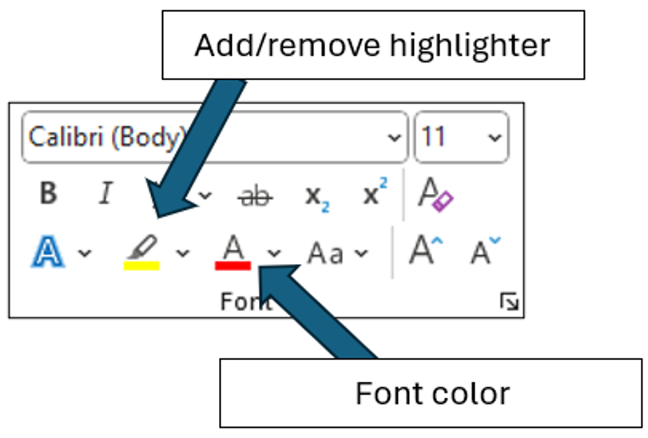

You’ll also see “Check your understanding” boxes throughout the template. These help you think through how to customize certain sections. After you’ve read and completed each one, simply right-click the box and select “Cut.”
Disclaimer. This sample safety program template cannot be used as is. You must customize the template to meet the needs of your organization. EMC does not guarantee that this template is or can be relied on for compliance with any law or regulation, assurance against preventable losses, or freedom from legal liability. We make no representations or warranties of any kind whatsoever, either express or implied, in connection with the use of this template. EMC will not be liable for your use of the template as customized by you. All safety programs and policies, including this template and the information you supply to complete it, should be reviewed by your legal counsel and/or risk management staff.

Fleet Safety Program (Non-DOT)

Purpose
The operation of motor vehicles is a necessary part of <COMPANY NAME> business. The operation of motor vehicles exposes our company to the risk of loss – through injury to employees or the general public, damage to property and to our company’s overall reputation. Therefore, as a part of management’s commitment to operate all aspects of the business in a safe and responsible manner, we have created the following Fleet Safety Program.
The purpose of this Fleet Safety Program is to detail the policies and procedures <COMPANY NAME> takes to minimize the frequency and severity of vehicle accidents. All employees are required to follow the procedures outlined in this program. Any deviations from this program must be immediately brought to the attention of the Fleet Safety Program Administrator.
Scope
This policy applies to all drivers of company-owned, leased, rented or borrowed vehicles and all drivers of non-owned company vehicles while being operated on company business regardless of the amount of time spent in the vehicle.
The Fleet Safety Program Administrator is responsible for the program’s implementation, management and recordkeeping requirements.

Program Responsibilities
Management. The management of <COMPANY NAME> is committed to the Fleet Safety Program. Management supports the efforts of the Fleet Safety Program Administrator by pledging financial and leadership support towards the identification and control of hazards related to motor vehicle operation.
Fleet Safety Program Administrator. The Program Administrator reports directly to upper management and is responsible for this program. All driver selection, vehicle maintenance, training and other program components will be coordinated under the direction of the Program Administrator in collaboration with management. The Program Administrator monitors the results of the program to determine needed modifications or additional areas of focus. The Program Administrator also performs the following duties:
- Evaluates applicants to determine if they are eligible to drive our vehicles or other vehicles on company business
- Authorizes those persons who are allowed to operate vehicles
- Ensures vehicles are maintained in safe condition
- Develops and enforces fleet safety rules and policies
- Investigates all vehicle accidents and recommends any necessary corrective actions
- Coordinates driver training programs (This should lead to the satisfactory completion of a road test)
- Coaches' drivers using telematic data to improve driving habits or develop a driver mentorship program to coach drivers (See Appendix G)
- Annually reviews this written program and makes any changes needed. Documents the annual review on the proper forms (found in Appendix A) and submits the report to upper management
Employees. Every employee of <COMPANY NAME> is responsible for conducting himself/herself in accordance with this program. Employee involvement is an essential element to the success of our fleet safety efforts. Employees may be solicited for their input regarding vehicle selection, safety features, training programs and other topics related to this program.
Driver Selection
will check the driving history of all applicants through the use of a Motor Vehicle Record (MVR) before they are granted driving privileges and obtain an updated MVR for all approved drivers annually thereafter. MVRs will also be checked whenever an employee is involved in a motor vehicle accident. A driver list is maintained and updated annually, including the last date of an MVR for each driver. The approved drivers' list will be recorded on the proper form found in Appendix B and maintained by the Program Administrator.
Employees will be prohibited from operating vehicles on company business under any of the following conditions:
- Employee is under 25 years of age
- Employee does not have a valid driver’s license, or the license has been suspended or revoked
- Employee does not have at least one year of verifiable driving experience
- Employee’s MVR indicates more than two at-fault accidents, or three moving violations, or two moving violations plus one at-fault accident in the past three years
- Employee’s MVR indicates any one of the following major violations within the past five years:
- Driving under the influence
- Reckless driving/speed contests
- Hit and run
- Vehicular manslaughter/homicide
- Leaving the scene of an accident
- Fleeing/eluding a police officer
- Passing a stopped school bus
- Speeding 15 or more miles over the speed limit
- Refusing a chemical test
- Operating with a suspended or revoked license
- Employee has tested positive in an alcohol or drug test while in our employment
Authorized Vehicle Use
The Program Administrator determines who is authorized to operate vehicles on company business. No employee or non-employee (for example, an employee’s spouse or child) is allowed to operate a company vehicle, or their own vehicle on company business, unless the Program Administrator has authorized that person to drive. Before any non-employee is permitted to use a company vehicle, he or she must meet the same qualifications as those for employees. Use of company vehicles by employees and non-employees under the age of 25 is prohibited.
Vehicle Maintenance
To extend the useful life of vehicles, regular inspections and maintenance will be completed on all company owned and operated vehicles per the manufacturer’s recommendations. If during an inspection any of the items are found “not okay,” the vehicle will be removed from service until it can be repaired or replaced. All problems must be promptly reported to the Program Administrator. Each driver will inspect the vehicle before each use. The inspection will consist of all items listed in the Vehicle Self-Inspection Report (form located in Appendix C). All vehicle Self-Inspection Reports will be submitted to the Program Administrator within one business day.
In states that require emissions testing, all vehicles will comply with the state’s requirements.
Driver Safety Rules
All motor vehicle operators must obey all state laws and posted signs when operating vehicles. In addition, the following rules must be followed at all times.
Cell Phones and Other Distractions. The use of handheld or hands-free cell phones, or other devices that take attention away from the driving task, are prohibited when driving company vehicles. Passengers may use devices only if the use will not be distracting to the driver. Cell phone calls should be made prior to or at the completion of a trip. If a call must be made during a trip, drivers must pull into a safe location and stop before making the call. If the driver receives an incoming call while driving, they must allow the call to go to voicemail and return the call when stopped in a safe location. Eating while driving is prohibited. Nonalcoholic drinks may be consumed with great discretion and only in situations where driving hazards are minimal (i.e., not in traffic, through road construction, etc.)
Seat Belts. Seat belts must be properly worn by all drivers and passengers while the vehicle is in operation. Children being transported in a company vehicle must remain properly secured in a child safety seat or booster seat according to state law.
Drugs and Alcohol. Drivers will not operate a motor vehicle at any time when his/her ability is impaired, affected or influenced by alcohol, illegal drugs, medication, illness, fatigue or injury. The sale, purchase, transfer or possession of any controlled substance (except medically prescribed drugs) is strictly prohibited while using a company vehicle, while on the company premises or while engaged in company business.
Severe Weather. Extreme caution must be exercised when driving in severe weather conditions. If a driver has any doubt about the safety of travel, they must contact their supervisor or the Program Administrator for guidance.
Radar Detectors. The use of radar detectors or any other device with the purpose of detecting or interfering with police radar is prohibited.
Glass. Damaged glass should be reported immediately to the Program Administrator. To reduce windshield damage, drivers will:
- Keep a safe distance between vehicles, especially on gravel roads
- Use clean, greaseless, dry cloths to wipe the windshield
- Replace worn wiper blades as soon as they begin to streak
- Use plastic or rubber ice scrapers, never metal
Towing. Only vehicles specifically approved for towing by the Program Administrator may be used to tow trailers of any size or type.
Traffic Violations and Citations
Drivers are responsible for all citations received. Traffic citations must be reported to the Program Administrator as soon as possible. The Program Administrator will review the driving privileges of any employee charged with a serious offense. Disciplinary action may include warnings, probation or suspension of driving privileges. For those jobs that require operation of a company vehicle, loss of driving privileges may result in termination.
Vehicle Accident Investigation. Vehicle accident investigations are handled internally and may utilize external documents such as police reports. Vehicle accident reports are to be filled out by the driver and returned to the Program Administrator as soon as reasonably possible. The Program Administrator will determine accident preventability and the proper course of disciplinary action that might be necessary. The Program Administrator will also determine if additional training is needed to prevent similar accidents from occurring in the future. Trends in types of accidents or multiple accidents caused by the same driver will receive additional scrutiny, as they may signal the need for additional training or changes to driver selection procedures.
When in an accident, drivers must:
- Stop your vehicle and protect the scene to prevent a secondary accident.
- Call for medical assistance and assist any injured people, if necessary.
- Call the police and the Program Administrator or supervisor as soon as possible.
- Locate any witnesses and get important information from them. If possible, get names, addresses and phone numbers.
- Exchange pertinent information with other drivers.
- Take photos of the accident.
- Fill out a vehicle accident report form and send it to the Program Administrator (forms are in Appendix D).
- Never admit fault or apologize. Apologies could be interpreted as an admission of fault.
- Never argue with other drivers or witnesses.
- Never argue with the police.
- Never make a statement to the media. Refer them to the Program Administrator.
- Never discuss details of the incident with anyone except a representative of or the police.
- Report every accident no matter how small to the Program Administrator.
Vehicle Accident Report forms must be kept in each company vehicle for use after an accident. If the vehicle you are driving does not have a Vehicle Accident Report form in it, contact the Program Administrator.

Driver Training. Upon initial assignment of driving privileges, each driver will be required to attend a training session that outlines the rules and procedures in our Fleet Safety Program. Ongoing training will be offered to all drivers, at least annually, to ensure they are kept up to date with defensive driving techniques and changes to the policies and program. Driver ride-a-longs may also be conducted upon initial hire and periodically thereafter as deemed appropriate by the Program Administrator. Training and retraining will be documented by the Program Administrator (Training Record/Certification forms are in Appendix E).

Periodic Program Review
At least annually, the Program Administrator will conduct a program review to assess the progress and success of the Fleet Safety Program. The review will consider the following:
- Evaluation of all training programs and records
- The frequency and severity of vehicle accidents during the previous year
- The need for changes to the Fleet Safety Program, based on evaluation of the program and results
- The need for changes to the driver selection/disqualification criteria
Record Retention
All records will be retained for Company specified number of years years.
Revision History
12/10/2024
Appendix A – Annual Evaluation Report
Date of Evaluation: | Evaluated by (list all present):
Written Program Reviewed: Yes No
Comments on Written Program:
Do vehicle accident records indicate a need for additional employee training on the program? Yes No
The following content was added/modified/removed from the written program:

Comments:

Appendix B – Driver List
Those listed below have been authorized to operate motor vehicles on company business and have received instruction regarding the <COMPANY NAME> Fleet Safety Program.

Employee Name | Date of Last MVR Check

Appendix C – Vehicle Self-Inspection Report
If an item is defective, check the box and give details in the remarks section.
Inspection Completed By: |  |  |  |  |  |  |  |  |  |  | Date:
Vehicle Make: |  |  | Model: |  |  | Year: |  |  |  | No.:
Beginning Mileage: |  |  |  |  | Ending Mileage:
Not OK | OK | Before Starting Engine |  |  |  |  | Not OK | OK | After Starting Engine
 |  | Body |  |  |  |  |  |  | Brakes
 |  | Brake/head/tail/clearance lights |  |  |  |  |  |  | Parking brake
 |  | Direction signals/emergency flashers (4-way) |  |  |  |  |  |  | Engine/drive train
 |  | Mirrors (inside and outside) |  |  |  |  |  |  | Gauges (oil/fuel/temp/air)
 |  | Windows/windshield |  |  |  |  |  |  | Heater/defroster/air conditioner
 |  | Wheels and tires |  |  |  |  |  |  | Speedometer
 |  | –Air pressure to manufacturers recommendation |  |  |  |  |  |  | Steering
 |  | –Minimum of ³/₁₆ inch tread depth |  |  |  |  |  |  | Transmission
 |  | –No visible sign of the tire deterioration |  |  |  |  |  |  | Other:
 |  | Windshield wipers and washers
 |  | Horn
 |  | Seat belts (all seating positions) |  | Remarks:
 |  | Seats securely fastened to the floor
 |  | Battery
 |  | Belts/hoses
 |  | Fluid levels/leaks
 |  | Muffler and exhaust system
 |  | License plate(s)
 |  | Suspension system
 |  | Fire extinguisher
 |  | First aid kit
 |  | Reflectors/flags/flares
 |  | Other:
Condition of above vehicle is Satisfactory Unsatisfactory
Signature:

Appendix D – Vehicle Report

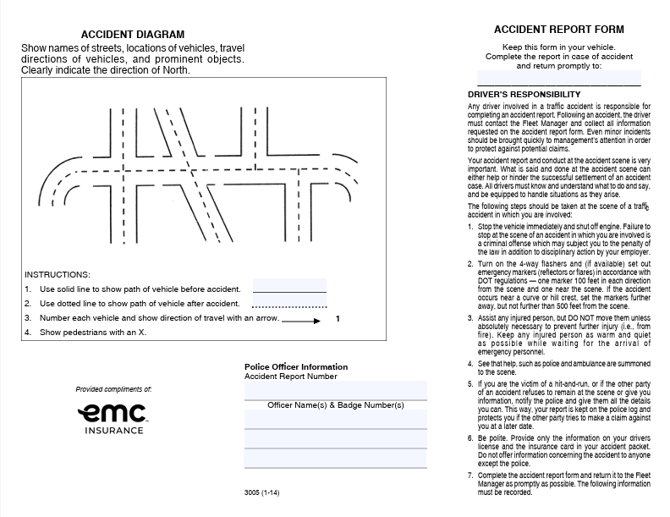
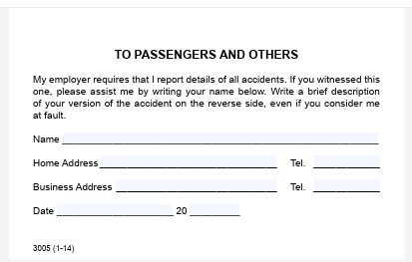
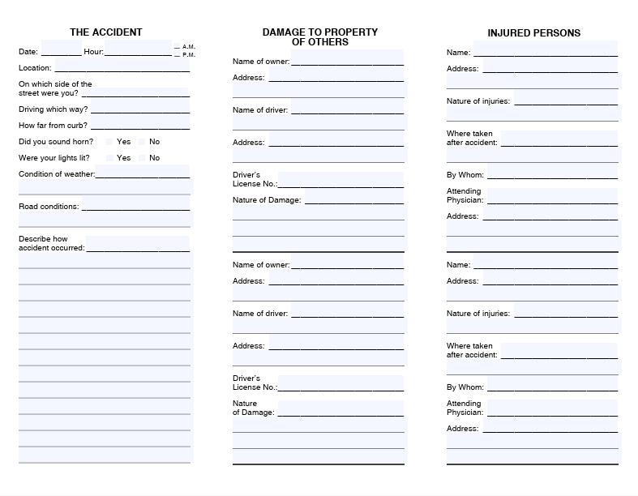

Appendix E – Training Record/Certification for Fleet Safety Program
This is to certify that the undersigned received training in accordance with the <COMPANY NAME> Fleet Safety Program.
Print Name | Sign Name

Print Instructor’s Name
Instructor's Signature
Instructor’s Title
Date of Training

Appendix F – Annual Motor Vehicle Report Review

ANNUAL REVIEW OF DRIVING RECORD

I certify that I have carefully reviewed the driving record of _____________________________ to determine whether he or she meets the minimum requirements for safe driving specified in this program or is disqualified to drive a commercial motor vehicle.

In reviewing this driver’s record, I certify that I have considered any evidence that the driver has violated any company rules or applicable regulations. I have considered the driver’s accident record and any evidence that the driver has violated laws governing the operations of motor vehicles. I have given great weight to violations that indicate that the driver has exhibited a disregard of the safety of the public and company policies, such as speeding, reckless driving, and operating while under the influence or alcohol or drugs.

A copy of the response from each state agency inquired is attached. This form shall be maintained in the driver’s qualification file.
_______________________________________ ______________________________________
Reviewer Name | Review Date
_______________________________________ ______________________________________
Title | Reviewed By Signature

Appendix G Driver Coaching Form
Driver Coaching Using Telematic Data
Driver’s Printed Name: | Date of coaching session
What is the company’s benchmark score for harsh driving events for the following categories:  Speeding  Harsh braking  Harsh cornering  Harsh acceleration  Distracted driving  Drowsy driving  Idle time  Based on the telematic data what harsh driving events are being observed by this driver over the established company benchmark? | What is the benchmark safety score for all drivers?  What is the current driver’s safety score?  Has the score improved or declined since last coaching session?
What additional training opportunities should be assigned to this driver based on harsh driving events? | When should the training be completed?
Is there a need for a follow-up session prior to the next scheduled coaching session?

If so, when?

Coach’s Printed Name: | Coach’s Signature

