Using this template

This guide is designed to help your organization build a written safety program.

You’ll need to customize the template to fit your organization—it’s not ready to use as is. We’ve made that process easier by adding visual prompts throughout the document. Look for yellow-highlighted, red text that shows where you need to add or update information.

You can (and should) change any part of the template to match your organization’s structure, such as department names, job titles, responsibilities, or procedures.

Example
Before:
<COMPANY NAME>
Sample Safety Program

After:
XYZ Company
XYZ Safety Program

Formatting tips
- To remove the yellow highlighting: Select the highlighted text, then click the highlighter icon in the Font menu.
- To change the red font to black: Select the text and click the font color icon.
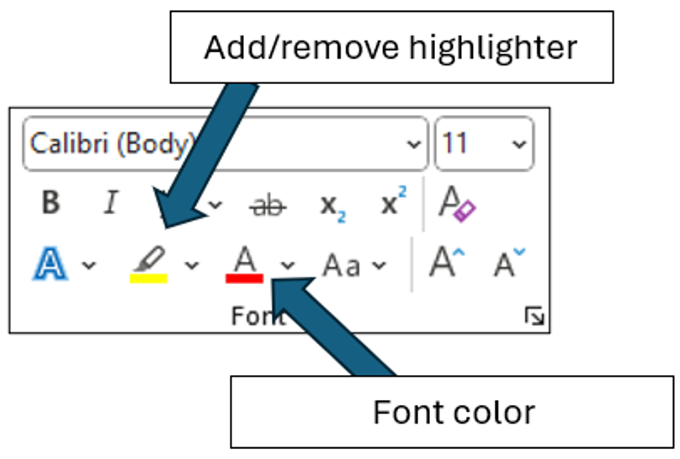

You’ll also see “Check your understanding” boxes throughout the template. These help you think through how to customize certain sections. After you’ve read and completed each one, simply right-click the box and select “Cut.”
Disclaimer. This sample safety program template cannot be used as is. You must customize the template to meet the needs of your organization. EMC does not guarantee that this template is or can be relied on for compliance with any law or regulation, assurance against preventable losses, or freedom from legal liability. We make no representations or warranties of any kind whatsoever, either express or implied, in connection with the use of this template. EMC will not be liable for your use of the template as customized by you. All safety programs and policies, including this template and the information you supply to complete it, should be reviewed by your legal counsel and/or risk management staff.

<Company Name>
Lockout/Tagout Program
(Control of Hazardous Energy)

Purpose and Scope
The purpose of <Company Name’s> Lockout/Tagout Program is to keep our employees safe by establishing appropriate lockout/tagout procedures for equipment that is powered by or capable of storing hazardous energy.
All employees are required to follow the minimum procedures outlined in this program. Any deviations from this program must be immediately brought to the attention of the Program Administrator.
Work will not begin until all forms of hazardous energy are identified and controlled to a zero hazardous energy level.
- Lockout is required if the work requires a person to place any part of their body into an area where a danger zone exists. Locks and/or lockout devices must be attached to the energy control point to keep the hazardous energy from being reintroduced to the equipment while work is being conducted.
- There may be multiple energy control points that affect work in a danger zone; each point must be identified and controlled.
- The lockout must provide complete energy isolation, without possible override. Note: push-buttons, selector switches, interlocks, emergency shutoffs, software controls and other control circuit type devices are not energy control points and cannot be used to fulfill this program.
- Work will not begin until all forms of hazardous energy are identified and controlled.
- All employees and contractors must have individual locks and keys such that the individual is the only person who possesses the key.
- Supervisory or foremen locks intended to protect a group of workers are not allowed. Employees working as a group must each have their own locks and utilize either a lock box or multiple user-locking devices.
- Any person entering any danger zone, regardless of the length of time, must apply his or her own lock and tag to the energy-isolating devices for that danger zone.
- In situations where it is impossible to install a lock or apply a locking device, contact the state OSHA offices for consultation and direction.
- This program does not apply to electric equipment for which electrical energy is the only energy source and it can be isolated and controlled by unplugging the equipment from the outlet and keeping the plug under the exclusive control of the employee performing the servicing or maintenance. Also, the program does not apply to installations under the exclusive control of electric utilities for the purpose of power generation, transmission and distribution.
- When the person who applied the lockout is not available to remove it, the abandoned lock procedure must be utilized. The removal of a lockout device has serious consequences and must not be taken lightly; refer to the program section Non-Routine Removal of a Lockout/Tagout Device.
Refer to Appendix A for a list of definitions.

Program Responsibilities
Management. <Company Name> is responsible for providing the tools and resources necessary to implement this program and for ensuring that the provisions in this program are being followed by the Program Administrator.
Program Administrator. The Program Administrator is responsible for the following:
- Developing specific lockout procedures for each individual piece of machinery/equipment at the facility
- Identifying who is included in each of the employee classifications – Authorized, Affected and Other
- Identifying the proper personal protective equipment (PPE) needed, if any, during the lockout/tagout procedures
- Providing the appropriate level of safety training to employees based on their classification
- Providing outside contractors working on <Company Name> equipment with training and information on <Company Name’s> Lockout/Tagout Program and procedures
- Review program at least annually or more frequently if changes are needed or new equipment is added
Supervisors. Supervisors are responsible for:
- Ensuring that only Authorized Employees who are qualified and trained apply and remove locks and tags
- Ensuring that employees who are found to have insufficient skills or understanding of lockout/tagout requirements do not perform lockout/tagout and receive retraining before conducting any lockout/tagout procedures
- Ensuring employees comply with all safe work practices described in this program
- Providing any information necessary for the success of this program to the Program Administrator

Employee Classification
Authorized Employee. An Authorized Employee is one who is trained to lock out or tag out a machine or piece of equipment in order to perform servicing or maintenance on that machine or piece of equipment. Duties of an Authorized Employee include:
- Completing all required lockout/tagout training
- Performing lockout/tagout activities listed in this program
- Retaining control of the equipment, system or machinery while a lockout/tagout is in progress and working only with their own lock and tag
- Keeping lockout/tagout hardware and tags in good condition

<Company Name’s> authorized employees are:
Names of Authorized Employees
1.
2.
3.

Affected and Other Employees. All employees whose job requires them to operate/use a machine or piece of equipment on which servicing or maintenance activities are being performed under lockout/tagout, or whose job requires them to be in an area in which lockout/tagout is being used, are considered “Affected” or “Other” employees. They are not authorized to implement lockout/tagout procedures.

Energy Control Procedures
The following steps are required each time lockout/tagout is performed.
Preparing equipment for lockout/tagout.
Basic procedure to de-energize equipment
The Authorized Employee should:
- Review the machine-specific lockout/tagout procedure to identify all forms of hazardous energy
- Identify the area of work and the lockout/tagout restriction zone
- Identify the proper control point of each source of hazardous energy
- Obtain lock(s), tag(s), and locking and/or blocking devices
- Notify workers of intent to de-energize—Affected Employees must be notified by the Authorized Employee prior to the application of any lockout or tagout device
- Begin shutdown, de-energize and dissipate any residual energy (springs, hydraulic pressure, water pressure, steam, flywheels, gravity, etc.) by blocking, bleeding down or other appropriate means
- Apply lockout devices to each energy source
- Once the lockout device has been applied, remove the key
- When more than one Authorized Employee will be working on a machine or piece of equipment, each Authorized Employee must apply their own lock or tag to the energy-isolation device; the key for each lock must be in the possession of the employee who applied the lock
- Confirm the equipment has been de-energized by initiating a normal startup procedure
- Ensure that no Authorized or Affected Employees are in the restricted area prior to attempting the restart of the equipment. Do not enter the machine until it is confirmed that all energy sources have been locked out
- When verification is complete, return the machine to the neutral or OFF position
- Wear the appropriate PPE
- Begin work
Restoring the equipment to normal operation when service is complete.
Basic procedure to remove lockout/tagout devices and reenergize the equipment
- Inspect the work area to ensure that all nonessential items, tools, etc., have been removed from the danger zone
- Check that all the guarding and safety controls have been properly replaced
- Notify Affected Employees and make sure all personnel are in a safe location prior to reenergizing the equipment
- Remove locks, tags and blocking devices
- Reenergize the equipment/system according to the start-up procedures specific to each piece of equipment
- Confirm the system is operating properly and safely before returning control of the equipment back to any Affected Employees
- Remove and clean or dispose of PPE
- Check locks, tags and lockout devices for damage or cleaning needs; replace as needed

Machine-Specific Lockout/Tagout Procedures
Machine-specific procedures outline the step-by-step process to be used for locking out each machine or piece of equipment. <Company Name> has established machine-specific lockout/tagout procedures for each piece of machinery and equipment in our facilities. A machine-specific audit form is available in Appendix E. A sample machine-specific template is available in Appendix F and a sample completed template is included in Appendix G.
Machine | Machine Specific Lockout/Tagout Procedures

Group Lockout
When a group of workers is assigned to service or repair a machine covered under this program, each employee will affix a personal lock to the group lockout device when he or she begins work and will only remove the device when he or she completes work on the machine.
If more than one Authorized Employee is required to lock out or tag out equipment, the following organizational procedures/structure shall be followed:
- A Primary Authorized Employee shall be designated to exercise primary responsibility for the implementation and coordination of the lockout/tagout of hazardous energy sources and for the equipment to be serviced
- The Primary Authorized Employee will coordinate with equipment operators before and after completion of service and maintenance operations that require lockout/tagout
- A verification system will be implemented to ensure the hazardous energy sources have been de-energized and continue to be isolated during maintenance and servicing operations
- Each Authorized Employee will be allowed to verify individually that the hazardous energy has been isolated and/or de-energized
- When more than one crew or department is involved, each separate group of servicing/maintenance personnel will be accounted for by a Principal Authorized Employee from each group
Note: The Principal Authorized Employee is an Authorized Employee who oversees or leads a group of servicing or maintenance workers such as plumbers or electricians. Each Principal Authorized Employee is responsible to the Primary Authorized Employee for maintaining accountability of each worker in that specific group.

Shift Changes
When work involving lockout/tagout extends beyond a single shift, the Authorized Employee going off shift shall not remove their lock and tag until an Authorized Employee coming on shift has placed their lock and tag on the energy-isolating device(s).
When equipment is scheduled to be taken out of service for an extended period of time, an Authorized Group Leader will also place a lock and tag on the energy-isolating device(s) until all work is completed and all other Authorized Employees’ locks and tags have been removed.
At no time during work should the machine be without the protection of a lockout device.

Non-Routine Removal of a Lockout/Tagout Device
When the Authorized Employee who applied the lock and any associated tags is not available to remove them, the devices may be removed by the Authorized Employee's supervisor in accordance with the process below:
- The Authorized Employee's supervisor(s) must verify that any Authorized Employee who applied lock(s) and associated tag(s) is not on duty and that their work is no longer in progress
- All reasonable efforts will be made to contact the Authorized Employee(s) to discuss the planned removal of their lock(s) and determine if the Authorized Employee(s) have any safety concerns with removal of their lock(s)
- An Authorized Employee/supervisor returns the equipment to service and notifies the Affected Employees that service or maintenance is completed and the equipment is ready for use
- When the Authorized Employee(s) whose lock(s) were removed return to work, their supervisor(s) will again notify them that their lock(s) and tag(s) were removed

Employee Training
Authorized Employees and Their Supervisors.
<Company Name> has developed and will provide lockout/tagout training on:
- The recognition of applicable hazardous energy sources
- The type and magnitude of the energy available in the workplace
- The methods and means available for energy isolation and control
- Removal of energy-control devices
Supervisors must supplement this general training with equipment-specific training for Authorized Employees under their supervision. Equipment-specific training will be accomplished by presenting applicable written procedures to Authorized Employees, verifying that they understand the requirements of the procedure and observing correct performance of the lockout/tagout procedure(s).
Affected/Other Employees.
- Affected Employees working in areas where lockout/tagout may be used will be trained on the purpose of the lockout/tagout program, identification of locks and tags and restrictions these impose on equipment operation
- Affected Employees must be retrained if a significant OSHA regulation or <Company Name> lockout/tagout guideline change has been made (i.e., new requirement, change in locks or tags)
- Affected Employee retraining can be delivered through awareness campaigns
- Other employees will be trained on the procedure and instructed never to attempt to restart or reenergize a machine that has been locked out or tagged out

Retraining of Authorized and Affected Employees.

Retraining is required if:
- • There is a change in task assignment that involves use of different lockout/tagout procedures for which the Authorized Employee has not been previously trained
- • There is a change in the machine, equipment or processes that presents new hazards
- • There is a change in the energy-control procedures
- • The supervisor has reason to believe or determines through a periodic inspection or observation that an Authorized or Affected Employee is performing the energy-control procedures inadequately, or has deviated from or lacks sufficient knowledge of established procedures
Record retention.
- All training records, including employee names and training dates, will be maintained in the <Location>
- Training records will be maintained indefinitely

See Appendices C and D for training records.

Periodic Program Review
All lockout/tagout procedures will be reviewed at least annually. The procedure will be reviewed for adequacy and completeness by an Authorized Employee who does not regularly use the machine/equipment-specific lockout procedure or by the Program Administrator. If any deviations or inadequacies are identified, the Program Administrator will take all necessary steps to update the procedure. The annual inspection will include a review between the reviewer and each Authorized Employee of that machine/equipment to determine if they understand their responsibilities. Annual inspections are documented with the information shown in Appendix B. This inspection record will be retained indefinitely.

Outside Contractors
Whenever outside personnel are contracted to repair machines where lockout/tagout is required, they will be informed of the energy-control procedures for each machine by the Program Administrator or an Authorized Employee. All necessary safety information will be communicated to the contractor before work commences. An Authorized Employee will assist the subcontractor in locking out the equipment per our machine-specific procedure, if needed.

Revision History
<Revision XX – August 1, 2025>
Appendix A – Definitions
Affected/Other Employee – An employee whose job requires him/her to operate or use a machine or equipment on which servicing or maintenance is being performed under lockout/tagout, or whose job requires him/her to work in an area in which such servicing or maintenance is being performed
Authorized Employee – An employee who is trained to lock out and tag out a machine or piece of equipment in order to perform servicing or maintenance on that machine or piece of equipment
Awareness Campaign – Communication authorized by the company for the purpose of informing employees about an issue or new policy that affects employee safety
Energized – Connected to an energy source or containing residual or stored energy
Energy-Isolating Device – A mechanical device that physically prevents the transmission or release of energy
Equipment – Includes but is not limited to machines (lathes, presses, etc.), facility mechanical systems (air handlers, elevators, utility lines, etc.), research equipment, equipment components and agricultural equipment
Employee Supervisor – An individual administratively in charge of an authorized employee assigned to perform maintenance or service requiring the use of locks or tags
Hazardous Energy – Electrical, mechanical, hydraulic, pneumatic, chemical, nuclear, thermal, gravitational or any other form of energy that could cause injury due to the unintended motion of energizing, start‐up, or release of such stored or residual energy in machinery, equipment, piping, pipelines or process systems

Lockbox – A toolbox-style box of rugged construction that is capable of receiving a hasp when the box is shut. When the hasp is attached, a person cannot enter the box until the hasp is removed
Lockout – The placement of a lockout device and tag on an energy-isolating device that ensures the energy-isolating device and the equipment being controlled cannot be operated until the lockout device is removed
Lockout Device – A device that holds an energy-isolating device in the safe position and prevents the energizing of a machine or equipment
Personal Protective Equipment (PPE) – Safety equipment used by Authorized Employees during the lockout/tagout procedures.
Point of Operation – The area where the work actually takes place; the place where tools and material meet
Program Administrator – The person responsible for researching, developing, administering and evaluating programs in response to the identified needs of the organization

Service and/or Maintenance – Workplace activities such as constructing, installing, adjusting, inspecting and modifying machines or equipment where the employee may be exposed to the unexpected energization or start-up of the equipment or release of hazardous energy (lubrication, cleaning unjamming of machines or equipment, making adjustments or tool changes, etc.)
Setting Up – Any work performed to prepare a machine or equipment to perform its normal operation
Tagout – The placement of a tagout device on an energy-isolating device to indicate that the energy-isolating device and the equipment being controlled may not be operated until the tagout device is removed
Tagout device – A prominent warning device which can be securely-fastened to an energy-isolating device to indicate that the energy-isolating device and the equipment being controlled may not be operated until the tagout device is removed.
Testing – A determination that machinery, equipment or equipment parts are de-energized involving the use of properly operating test equipment designed for and capable of determining if any energized conditions exist
Verification – Operation of equipment controls for the purpose of determining that equipment cannot be restarted after an energy-isolating procedure has been performed and before maintenance or repair work is initiated

Appendix B – Annual Evaluation Report
Date of Evaluation: | Evaluated By (list all present):
Written Program Reviewed: Yes No
Comments on Written Program:
The following specific procedures have been reviewed:
The following specific procedures were modified:
The following specific procedures were added:
A review of the log of occupational injuries and illnesses (OSHA Form 300 or equivalent) and the associated accident reports and injury and illness reports were made: Yes No
The following injuries resulted from failure to use correct lockout/tagout procedures:
If injuries are listed above, indicate procedure number for applicable equipment, process, or machinery:
Comments:
Appendix C – Authorized Employee Training Record
This is to certify that the undersigned received training in accordance with 29 CFR 1910.147(c)(7) and the provisions of <Company Name’s> Lockout/Tagout Program.

Print Name | Sign Name

Print Instructor’s Name
Instructor’s Signature
Instructor’s Title
Date of Training

Appendix D – Affected/Other Employee Training Record
This is to certify that the undersigned received training in accordance with 29 CFR 1910.147(c)(7) and the provisions of <Company Name’s> Lockout/Tagout Program.

Print Name | Sign Name

Print Instructor’s Name
Instructor’s Signature
Instructor’s Title
Date of Training

Appendix E – Machine-Specific Energy Identification Form
Equipment:
Location:
Surveyed by:
Date of survey:
Energy Source Present | Magnitude of Energy | Method to Isolate  Energy Source | Verification Procedure
Electrical
Pneumatic
Hydraulics
Water under pressure
Gas under pressure
Steam under pressure
Gravity
Thermal (heat)
Chemical
Mechanical
Other:
Other:
Notes:

Appendix F – Machine-Specific Lockout Procedure
Machine Utilizing This Procedure: __________________________________________________________

Purpose
This procedure establishes the minimum requirements for the lockout of energy-isolating devices whenever maintenance or servicing is done on this machine or equipment. It shall be used to ensure that this machine or equipment is stopped, isolated from all potentially hazardous energy sources and locked out before employees perform any servicing or maintenance where the unexpected energization or start-up of the machine or equipment or release of stored energy could cause injury.

Compliance With This Program
All employees are required to comply with the restrictions and limitations imposed upon them during the use of lockout. The Authorized Employees are required to perform the lockout in accordance with this procedure. All employees, upon observing a machine or piece of equipment which is locked out to perform servicing or maintenance, shall not attempt to start, energize or use that machine or equipment.

Photos: Optional But Desirable

Procedure for Controlling Hazardous Energy
- Notify Affected Employees that may also work on or near the machine that the machine is about to be shut down and locked out.
- Be familiar with the sources of hazardous energy for the machine or equipment that will be serviced.
  - Energy Source and Magnitude: ___________________________________________________
- Shut down the machine using the normal stopping procedure.
- Isolate all energy sources listed above.
  - Isolation Procedures: ___________________________________________________________
- Verify that the machine is locked out by pressing the START button. No power should be present. Return control to OFF position.
- The machine is now locked out and work may begin.

Procedure for Placing Machine Back in Service
- Check the machine to make sure it is operationally intact, tools have been removed, and guards have been replaced.
- Check to be sure that all employees are safely positioned.
- Verify that the controls are in neutral.
- Remove the lockout devices and blocking and reenergize the machine or equipment.
- Restore energy to the machine.
- Notify all other Affected Employees that the machine is ready for operations.

Appendix G – Example of Completed Machine-Specific Lockout Procedure
Machine Utilizing This Procedure: Blowmatic
Purpose
This procedure establishes the minimum requirements for the lockout of energy-isolating devices whenever maintenance or servicing is done on this machine or equipment. It shall be used to ensure that this machine or equipment is stopped, isolated from all potentially hazardous energy sources and locked out before employees perform any servicing or maintenance where the unexpected energization or start-up of the machine or equipment or release of stored energy could cause injury.

Compliance with This Program
All employees are required to comply with the restrictions and limitations imposed upon them during the use of lockout. The Authorized Employees are required to perform the lockout in accordance with this procedure. All employees, upon observing a machine or piece of equipment which is locked out to perform servicing or maintenance, shall not attempt to start, energize or use that machine or equipment.
Electric
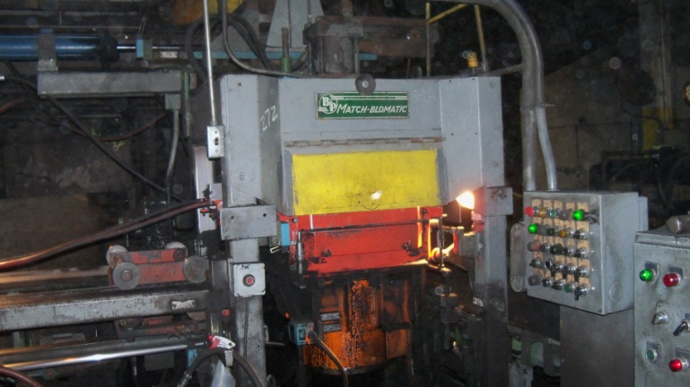
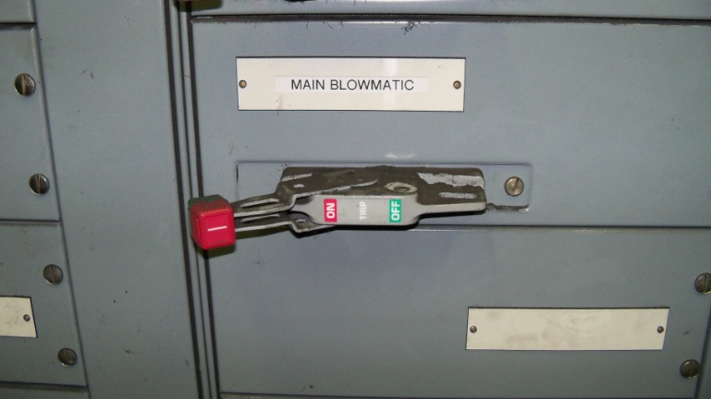
Air | Hydraulic

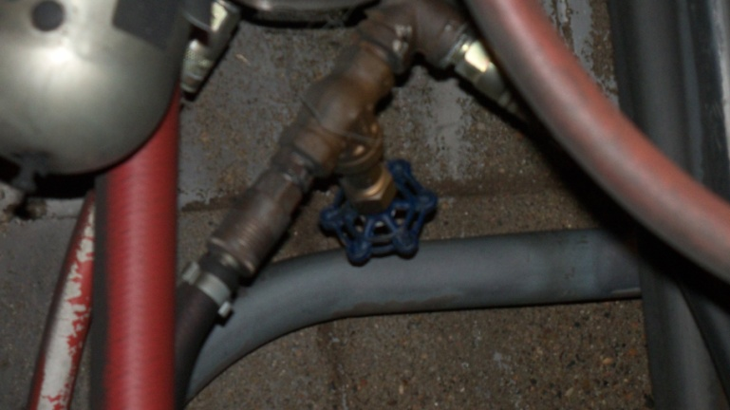
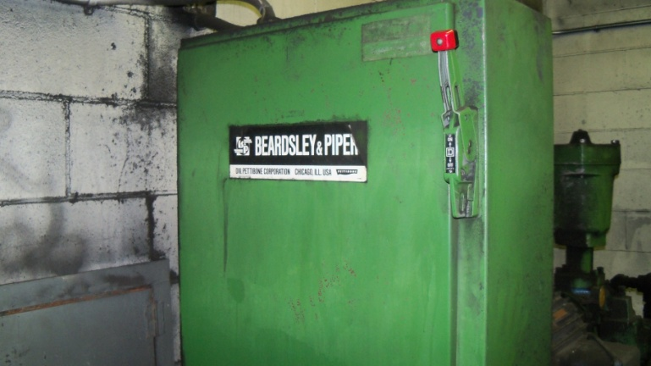

Procedure for Controlling Hazardous Energy
- Notify Affected Employees that may also work on or near the machine that the machine is about to be shut down and locked out.
- Be familiar with the sources of hazardous energy for the machine or equipment that will be serviced.
  - Electrical – 480 volts
  - Air – 100 psi
  - Hydraulic – 650 psi max, powered by 480-volt motor
- Shut down the machine using the normal stopping procedure.
- Isolate all energy sources listed above.
  - Electrical – Move wall disconnect to OFF position. Apply lock to switch.
  - Air – Apply cover over gate valve. Apply lock. Bleed off any stored air pressure.
  - Hydraulic – Move electrical disconnect to OFF position. Apply lock to switch. Bleed off any stored hydraulic pressure.
- Verify that the machine is locked out by pressing the START button. No power should be present. Return control to OFF position.
- The machine is now locked out and work may begin.

Procedure for Placing Machine Back in Service
- Check the machine to make sure it is operationally intact, tools have been removed and guards have been replaced.
- Check to be sure that all employees are safely positioned.
- Verify that the controls are in neutral.
- Remove the lockout devices and reenergize the machine or equipment.
- Restore energy to the machine.
- Notify all other Affected Employees that the machine is ready for operations.

